Setting up Mobile PC for AgeVisorTouch

The Mobile Touch PC (Pipo) is a 7” touch screen PC that runs two Operating Systems, Android and Windows10. The Mobile PC must be set to using Windows 10 for AgeVisorTouch.
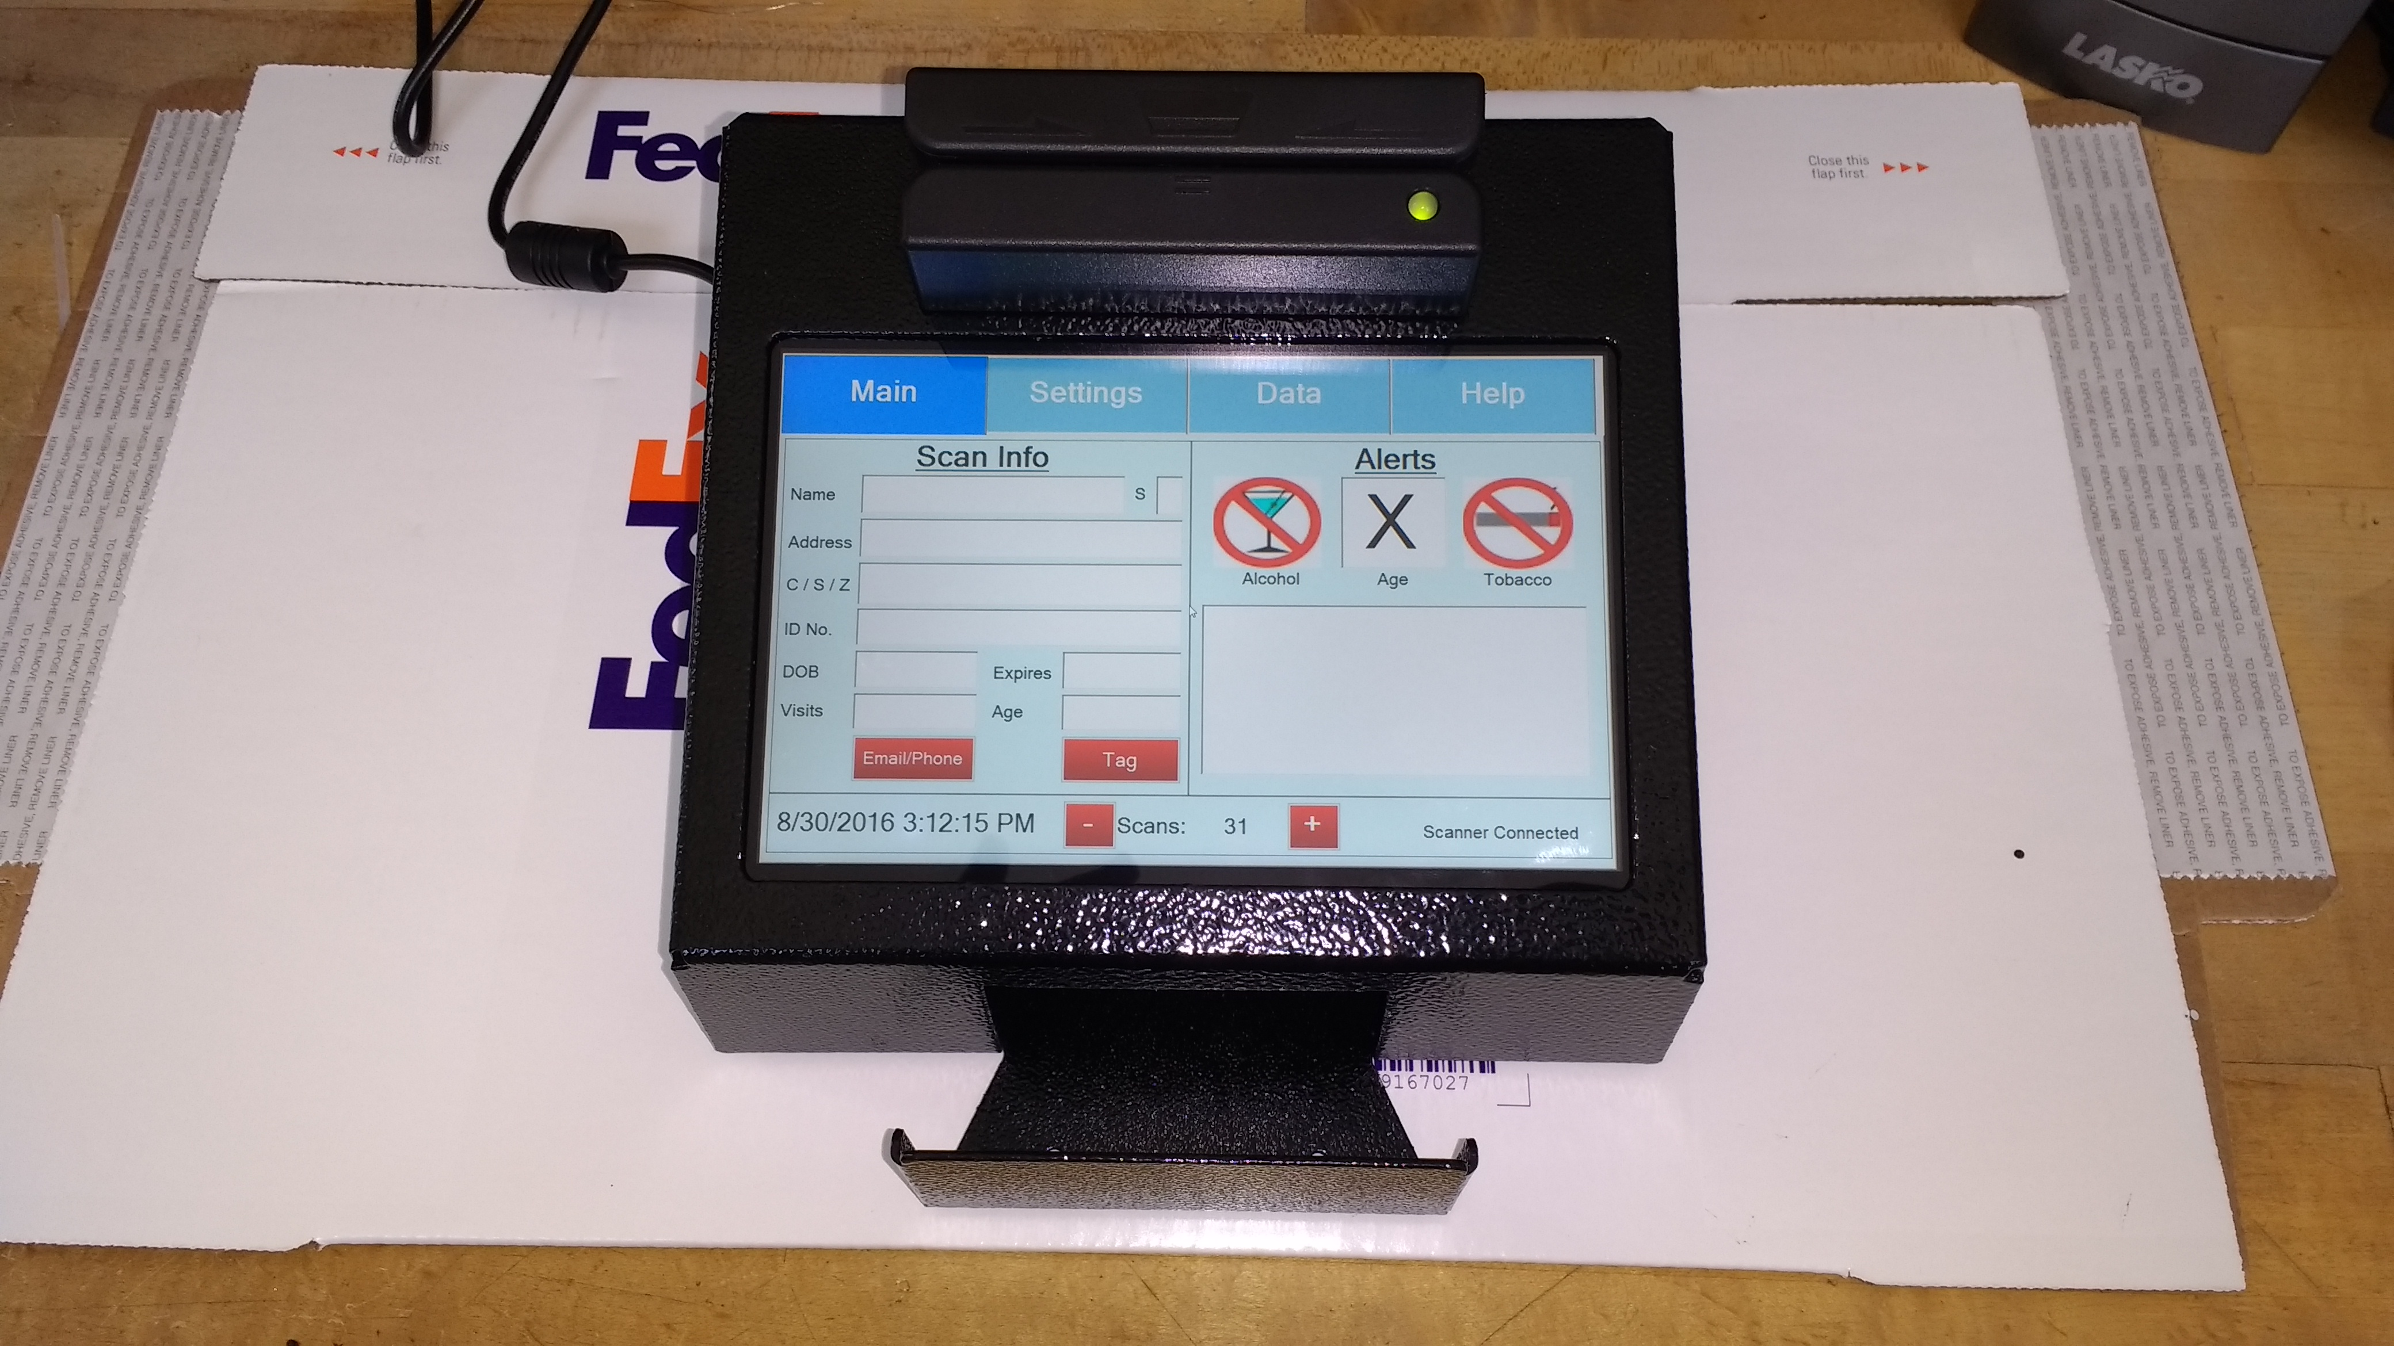
Contents
Equipment needed: 4
Windows Setup: 5
User Account creation 5
Flashing BIOS and Resetting Windows 5
System Settings 5
Set the Power & Sleep: 6
Set the Time and Language: 7
Set Notifications: 7
Turn Off Windows Update Feature 7
Windows Update Properties 9
Setting the wallpaper, loading background, and UserAccount Icon 10
Saving Serial Number: 10
Turning Off UAC 10
Installing AgeVisor Touch Software 11
Set the App to Auto start on Boot before Activating or running the app. 11
Set AgeVisor Touch to Run as an Administrator: 12
Activation AgeVisor Touch 13
Connecting and Configuring the Scaners 14
Registering the m420 14
Programming the MSR 14
Placing the Pipo into the Case: 17
Installing the Power Jack cable 22
Installing the m420 23
Installing the MSR 24
Testing Scanners with AgeVisor Touch 25
Finishing enclosing the case 26
Finished AgeVisor Touch 28

Equipment needed:
- Pipo x8 TV with power cable
- USB Drive with AgeVisorTouch installer, wallpaper image, user account image, and the AgeVisorTouchStartup.vbs file
- USB Drive with Windows installation (if BIOS is not already programmed to include Tokenworks boot up screen)
- BIOS Installation files on the same flash driveas the AgeVisor Touch installer (if BIOS is not already programmed to include Tokenworks boot up screen)
- USB mouse and keyboard*
- AgeVisor Key code
- Stickers
- AgeVisor Case
- Screws needed to mount case
- M420 Scanner, cable, and right angle USB adapter
- MSR Scanner, cable and right-angle USB adapter
- Short power cable extender
*The USB mouse and keyboard is only necessary to make it easier to change the settings

Windows Setup:

Turn on the PC and Select Win10 as the Operating System to Boot.
There is an option in the corner of the Operating System selection screen for choosing to no longer see the selection screen when booting. Change this option to not have a checkmark.
Connect a USB mouse/keyboard bluetooth dongle to the powered up PC, to help setup the device.

User Account creation
When Windows 10 boots for the first time it will require an account on the computer to be created. The account should be named “AgeVisor Touch”. No password should be set for the account, so that the computer automatically logs in when it boots.
If the customer’s location is known, choose the appropriate time zone, otherwise choose Easter, Time Zone. All other settings should remain on the default.
NOTE: The only time you will need to activate Wi-Fi will be during Activation of the AgeVisor app, keep Wi-Fi turned off to avoid the win10 from downloading an activating misc. apps and features.
The Win10 has an icon in the lower left corner that looks like a 4 pane window; this will be referred to as the “start button” like in previous versions of Windows

Flashing BIOS and Resetting Windows
In order to get the Tokenworks logo to appear on boot, we need to flash the BIOS. Copy the contents of the “Bios stuff” folder to the Desktop. Run the FLASHWin32.bat file. After that is done, the Pipo should reboot. Insert the Windows USB drive into the Pipo and select the Windows icon from the Dual boot menu and have the checkbox in the corner unchecked. Windows will reconfigure itself automatically. The settings should not change from the account you just created.

System Settings
If the PC display is not oriented to the landscape, shake it to get the display set to proper orientation=Landscape while working with this procedure.
Move any icons other than Recycle Bin and Computer to the Recycle Bin and empty the Recycle Bin.
Set Desktop Mode, to make the OS more familiar to a traditional Desktop PC:
Click on start button and select Settings.
Go to Settings-> System -> Display.
Set the Orientation to Landscape and Lock the Rotation
Go to Settings->System->Tablet Mode.
Set Tablet Mode=OFF.
When I sign in = Go to the desktop.
When this device automatically switches tablet mode on or off = Always ask before switching
Hide app icons=OFF

See reference screen shot on next page:

Tablet Mode = Off
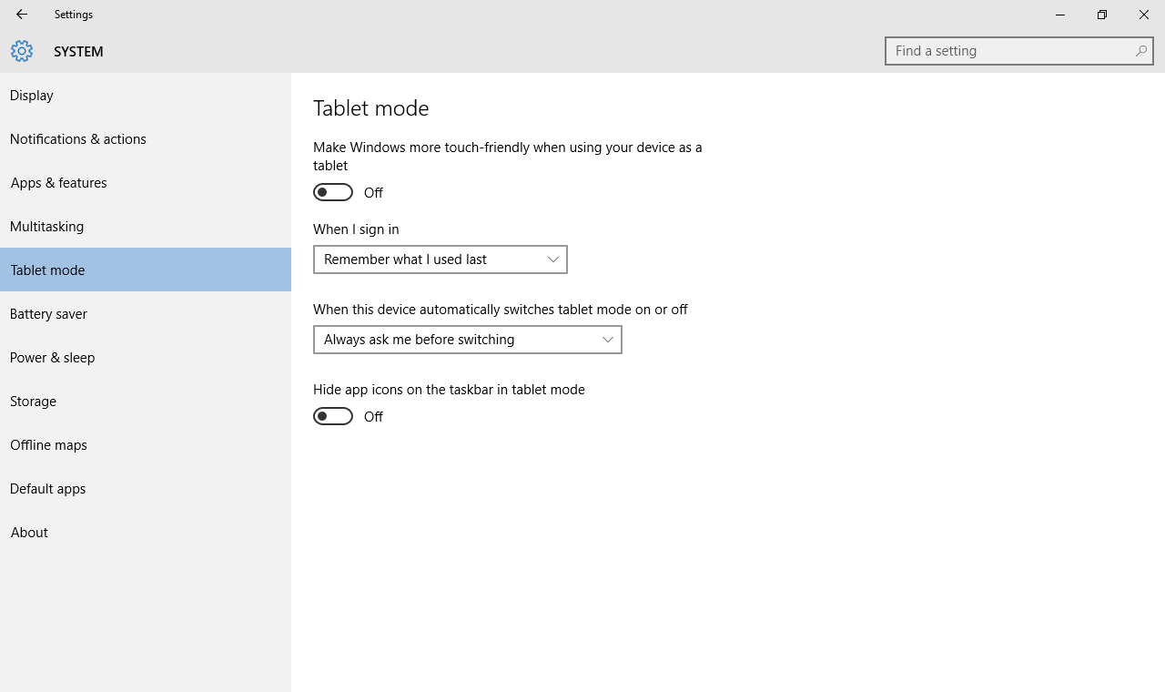

Set the Power & Sleep:
Go to Settings->System->Power & Sleep: Screen = Never Turn Off, Sleep = Never Sleep, Wi-Fi = Unchecked for connect while asleep

Set the Time and Language:
Go to Settings->System->Time & Language, set the correct time zone and time/date and ensure Country is set to United States.

Set Notifications:
Go to Settings->System->Notifications&Actions and set all Notifications to OFF.
Hide the Task Bar – THIS STEP IS Optional, and can be disregarded for now, Status is TBD
With a mouse, hover over the start button, and right click to show traditional windows maintenance apps, click on the Control Panel item.
On the control panel click on Appearance and personalization and then select Taskbar and Navigation. On the taskbar and start menu properties window, there are three checkboxes:
Check the Lock the Taskbar box
Check the Auto Hide the Taskbar box
Uncheck the Use small task bar buttons box
Make sure the Taskbar location is set to Bottom of screen, and then hit apply to affect the change.
NOTE: After this step, the taskbar will hide, and can be brought up by moving the mouse to the bottom of the screen or by pressing the windows button on the bezel.

Turn Off Windows Update Feature
The following screen shot will help guide you to stopping and disabling the Windows Update feature. Windows 10 will attempt to download and install updates whenever it is connected to the Internet which can be disruptive and may impact the usability of the age verification app.
Drag the mouse to the task bar at the bottom of the display and right click the mouse, and select the Task Manager. In the Task Manager app, go to the Services Tab.

Task Manager->Services
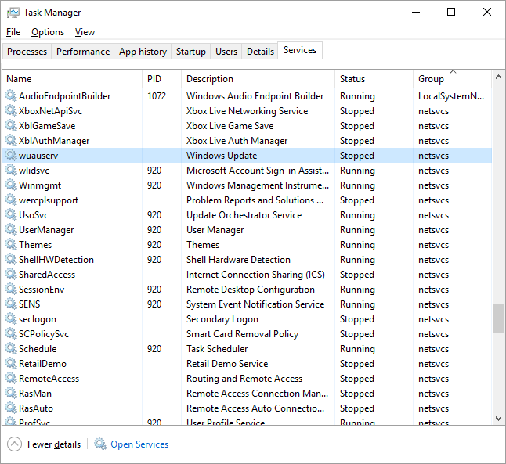
Click on the Open Services icon at the bottom of the Services page:

Services->Open Services
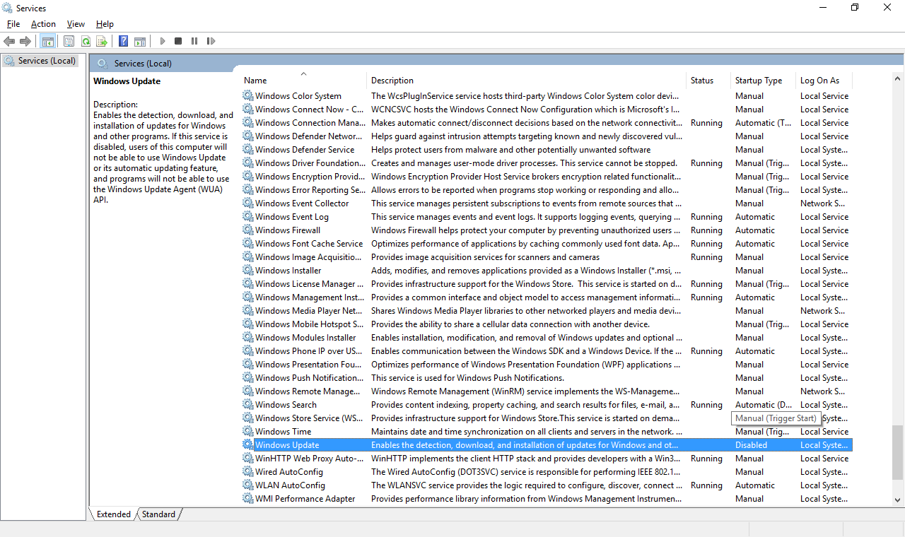

Find the Windows Update entry in this list, near the bottom, click on the item to highlight, and then right click to display Properties.

Windows Update Properties
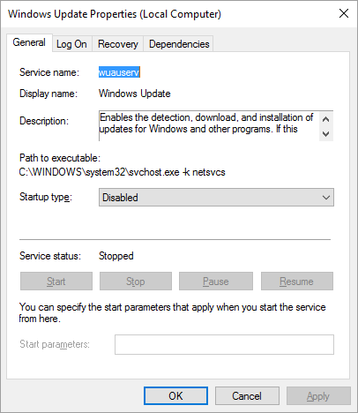

First, stop the service by clicking the stop button near the bottom. Then in the Startup type menu, select Disabled, and then hit the Apply button. The screen should appear like the picture above.

Setting the wallpaper, loading background, and UserAccount Icon
Copy the wallpaper image from the USB drive to the Documents folder. Right-click on the Desktop background and choose Personalize. Set the Background to Picture and then Browse and Select the picture you just copied to the Documents folder.

Next go to Settings -> Personalization -> Colors. If the unit is going to a dispensary, select a shade of green. Otherwise, select a shade of blue.

Next go to Settings->Personalization -> Lockscreen. Set the Background to Picture and then Browse and Select the picture you just copied to the Documents folder.
Next click on the Windows Start icon and click on the User Account icon on the top or bottom depending which Windows 10 Update has been installed on the Pipo. Choose the option to “Change account settings”. Under the option for Create a picture, click “Browse for one”. Navigate to the agevisor.png picture that accompanies the installer.

Saving Serial Number:
There should be a Serial Number for the unit located on the bottom of the device. Create a Device.txt document and type that serial number into the document. Save the document in the Documents folder. Go to the Z: drive and the Age Visor – Touch folder. In the AgeVisor Touch Sales History spreadsheet save the serial number.

Turning Off UAC
Now you need to turn off notifications in the User Account Control settings.
Right-click on the Start button and choose Control panel
Click on User Accounts and then Click on the User Accounts option in the new window.
Click on the option that says Change User Account Control settings
Select the bottom notch from the User Account Control Settings window and press OK.
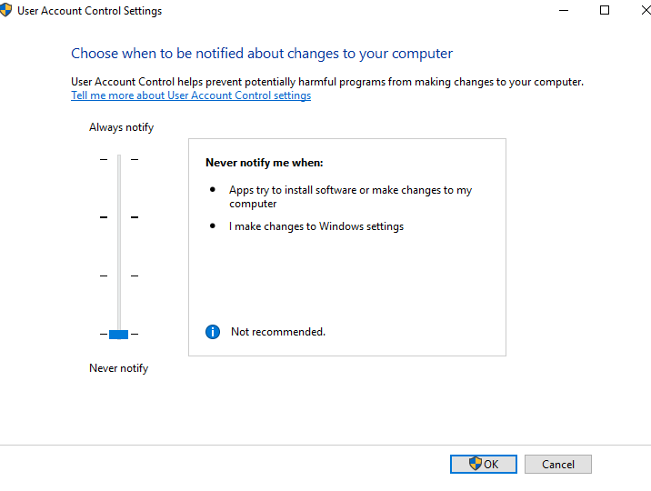

Installing AgeVisor Touch Software

The AgeVisorTouch installation package is a self -extracting archive that installs the application onto the PC at the path: C:\Tokenworks\AgeVisorTouch. The app also creates shortcuts to the start menu and the desktop. The archive is typically copied from a USB memory stick or from a network drive. After copying the file to the Pipo, run file explorer to find the file and run it.
File explorer:
Right click on the start button and select file explorer and navigate to the location of the AgeVisorTouchInstaller.exe and run it.

Set the App to Auto start on Boot before Activating or running the app.

The application will take up the full screen once it is activated, and you will not be able to easily work with the PC to finish this procedure. Before you run the app to activate it, do the following:

Right-click the AgeVisorTouchStartUp.vbs file and choose copy.
Right click on the Start button and Select Run, and then drag the screen that appears to the top of the display so you can use the touch keyboard to type in the command.
In the Run box type the following command. shell:common startup
An explorer window will appear with the following path:
C:\Program Data\Microsoft\Windows\Start Menu\Programs\Startup
In this explore window, right click the mouse and select Paste, the shortcut from the desktop should now appear in the folder.
Next you can move all the shortcuts from the desktop (except AgeVisorTouch) to the My Documents folder or some other folder that users will not see.

Set AgeVisor Touch to Run as an Administrator:
Open the AgeVisor Touch folder located at to C:/Tokenworks/AgeVisorTouch/
Right-click the AgeVisorTouch application file and choose Properties.
In the Properties window, go to the Compatibility tab, check the box that says “Run this program as an administrator.
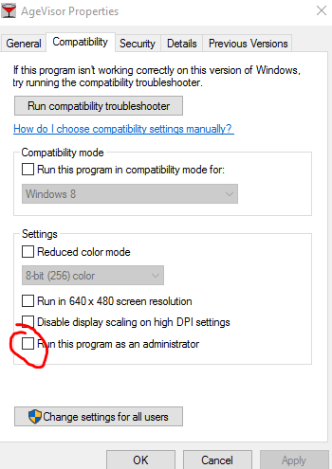

Activation AgeVisor Touch
The last step is to activate the application, using an activation code and the internet.
Type in the Activation code, including the dashes, and click on Auto Activate. (or paste in the code)
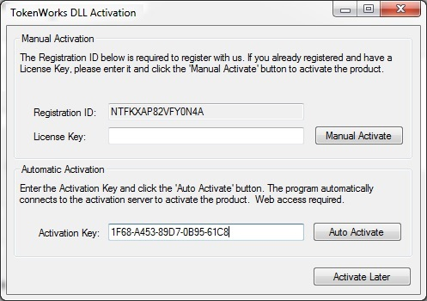

You should see the following screen if the activation was a success:
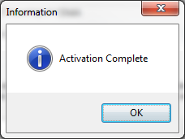

You can now reboot the PC to ensure that AgeVisor automatically starts in the Desktop mode.

Connecting and Configuring the Scaners

Located the two scanners you will be using for the AgeVisor Touch – The m420 and the Magnetic Stripe Reader).

Registering the m420
- Plug the m420 into a computer’s USB port
- Go to the Device Manager
- Check whether the m420 is listed as a POS HID Barcode Scanner or a HID-compliant device
- If the m420 is listed as a POS HID Barcode Scanner, right-click on the device in the Device Manager and choose Update Driver Software -> Browse my computer for driver software -> Let me pick from a list of device drivers on my computer -> Select HID-compliant device and then click next. This should change how the computer recognizes the m420 and allow you to run the Scanner Reg app.
- Open the Scanner Registration App. Go to Configuration -> Scanner Settings. Check the box that says FM420 Scanner enabled and press Done. Click Open Port -> Read S/N -> Load S/N -> Type the RegCode using the 1MMYY121 format -> Click Load Reg Code -> Program Registration # -> IDWedge Setting -> Verify Settings. You should now see a message appear that the scanner was registration. After seeing this message press Close port and Clear.

Programming the MSR
- Plug the MSR into a computer that has MSR213V & MSR 120D Demo Application (MSR App) installed
- After the MRS is plugged in, run the MSR App. When the program launches it should automatically recognize the COM port that the MRS is plugged into. If it doesn’t, disconnect the MSR, close the MSR program and reconnect the MSR and re-start the program.
- Click the option in the bottom-right to Self-Arm

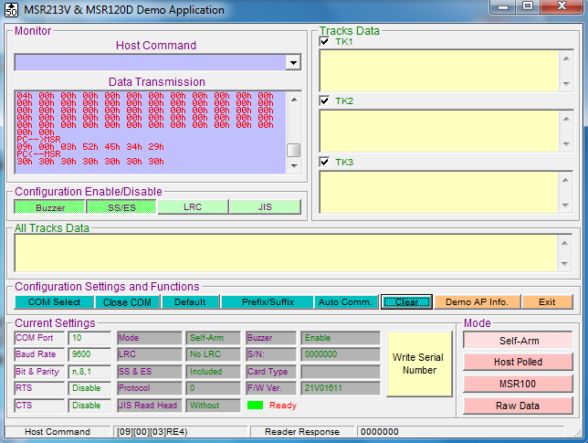
- Click on the Prefix/Suffix Code Setting button and enter the same values and then press OK
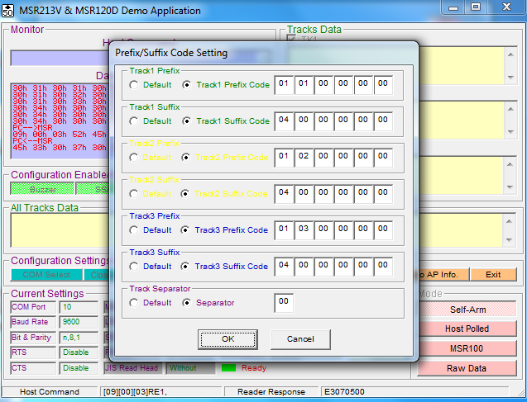

- After returning to the main window, Press MSR100 and then Auo Comm.
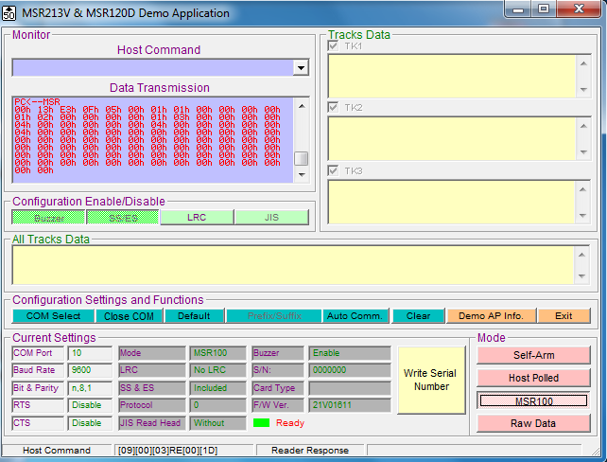

- After the Auto Comm. finishes press Close COM and then disconnect the MSR.

Placing the Pipo into the Case:
The AgeVisor Touch case consists of four large metal parts that tightly fit together to enclose the Pipo unit. The order of assembly is important since the pieces will not fit together correctly if a different order is followed.
Below is a picture of the pieces of the case:
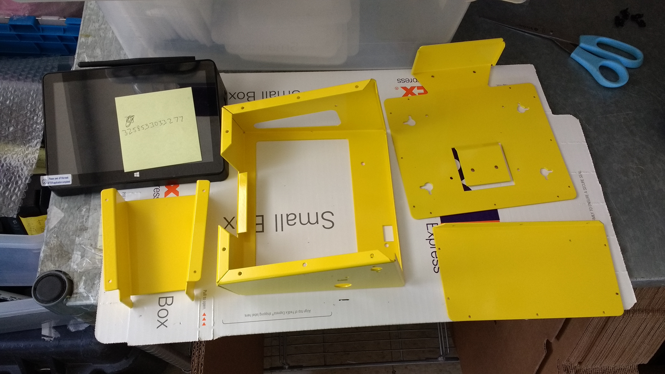

Before placing the Pipo into the case, you will need to remove the outer screen protector on Pipo. There should be two layers of screen protector. Remove the outer one like shown below:
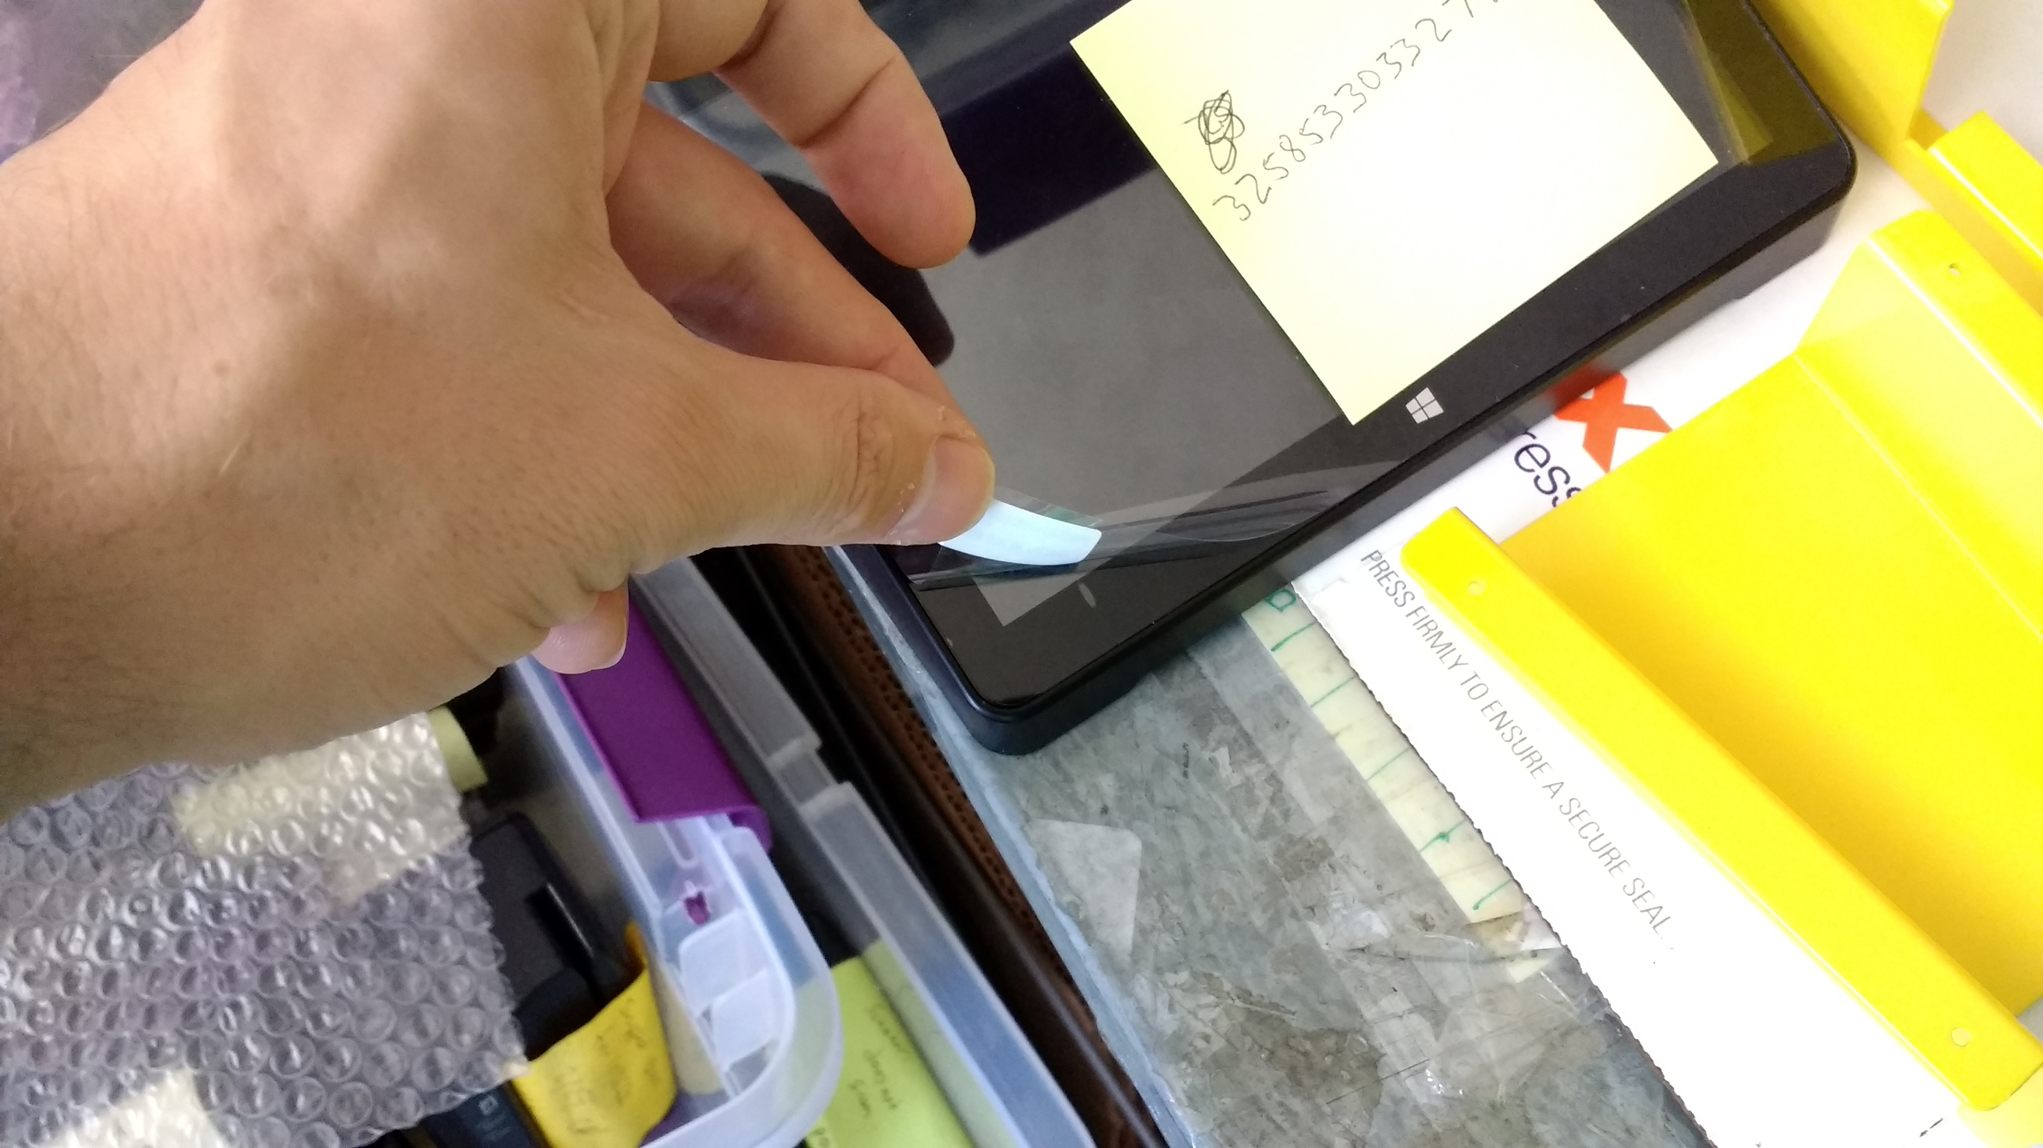

Next, place the Pipo caseinto the largest case part as shown in the image below. You may need to bend the case a bit to fit the Pipo into the case.
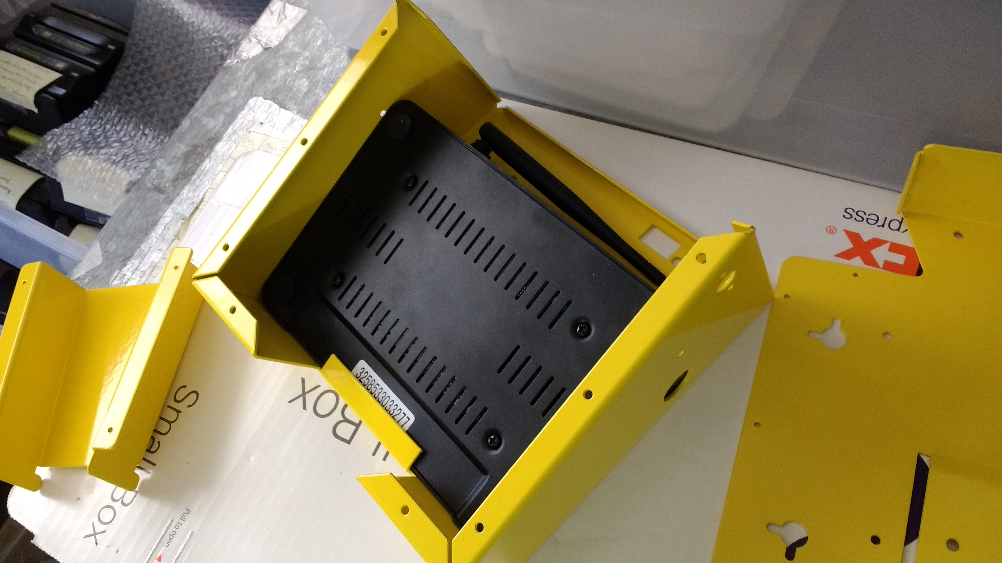

After the Pipo is in its slot, place the bottom plate into the main case. Again you may need to bend the case at bit to fit the bottom plate into place.
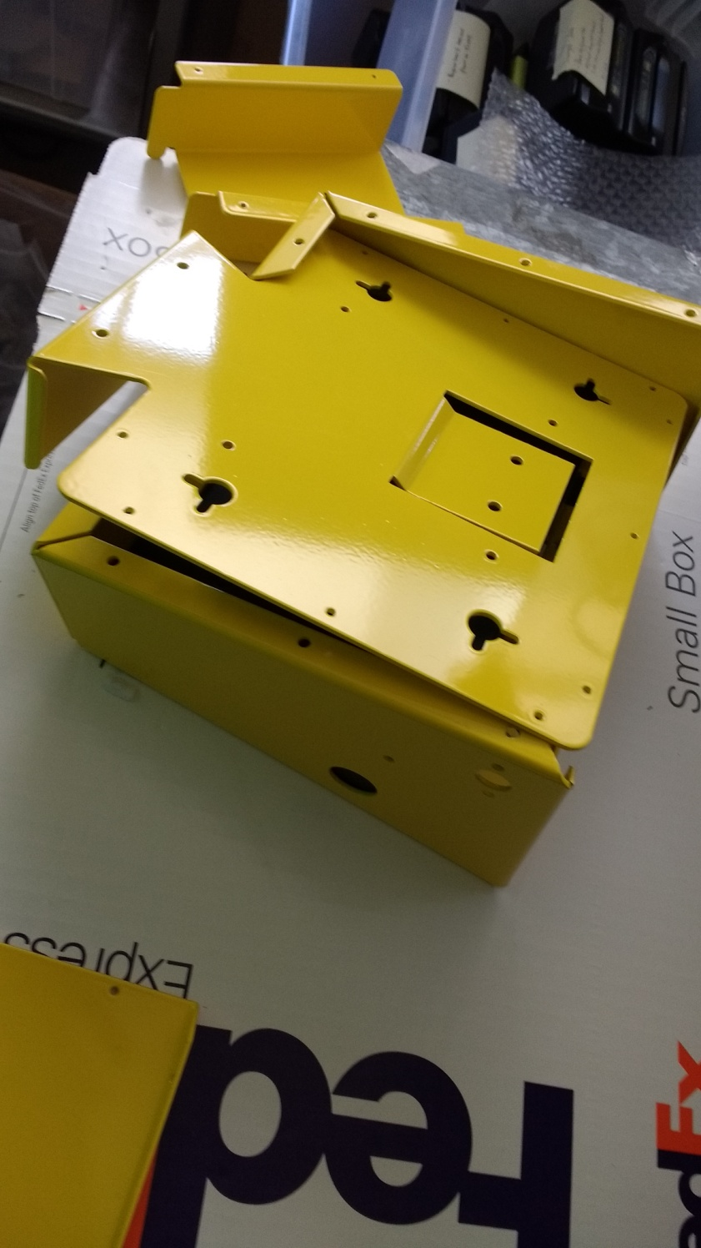

After the bottom plate is in, take the U-shaped piece and squeeze slide it between the bottom of the case and the Pipo. The flat metal side should line rest against the Pipo to act as a heat sink. There are two angled hooks that press against the Pipo for easier placement
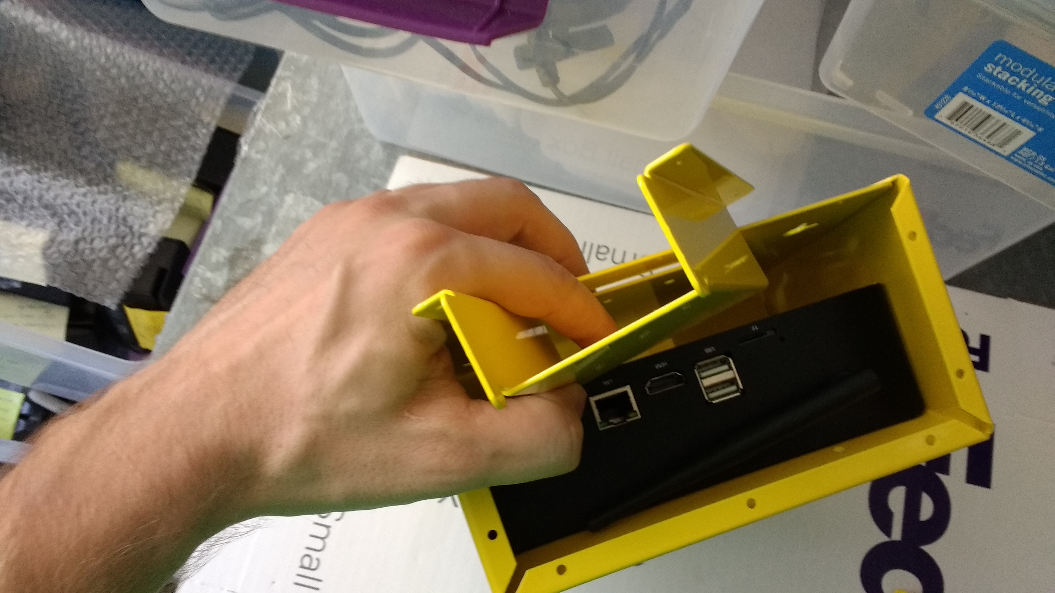

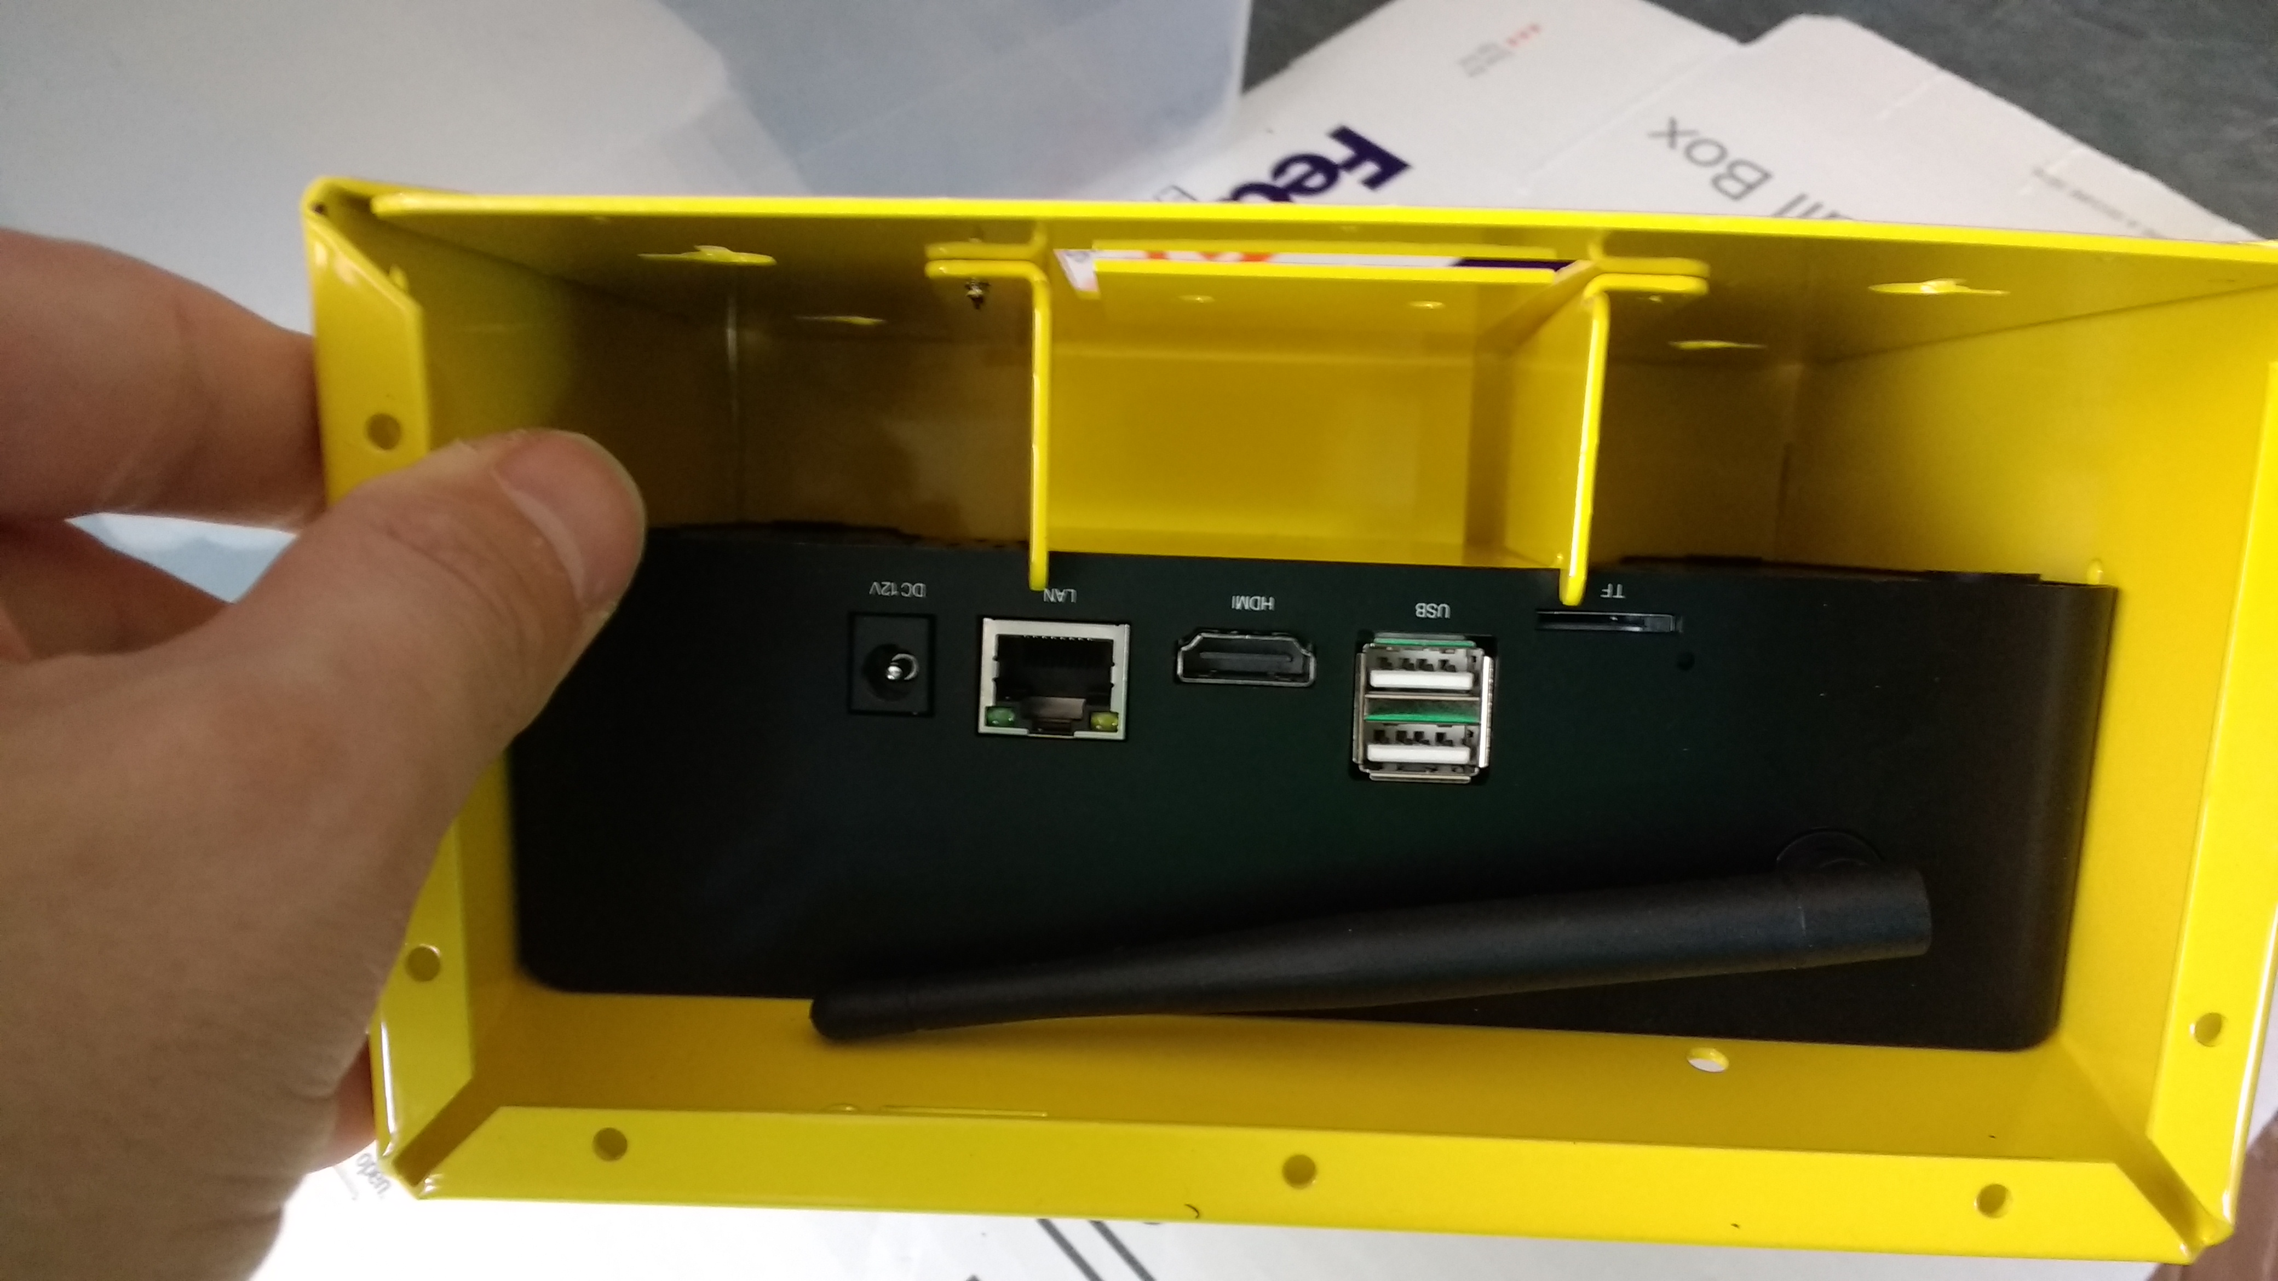

After the U-Shaped piece is in place, line up its holes with the bottom bracket and secure it with four case screws through the bottom.

After the U-Shaped bracket is secured, apply the two screws on the bottom of the case to begin attaching the bottom of the case to the main body of the case.
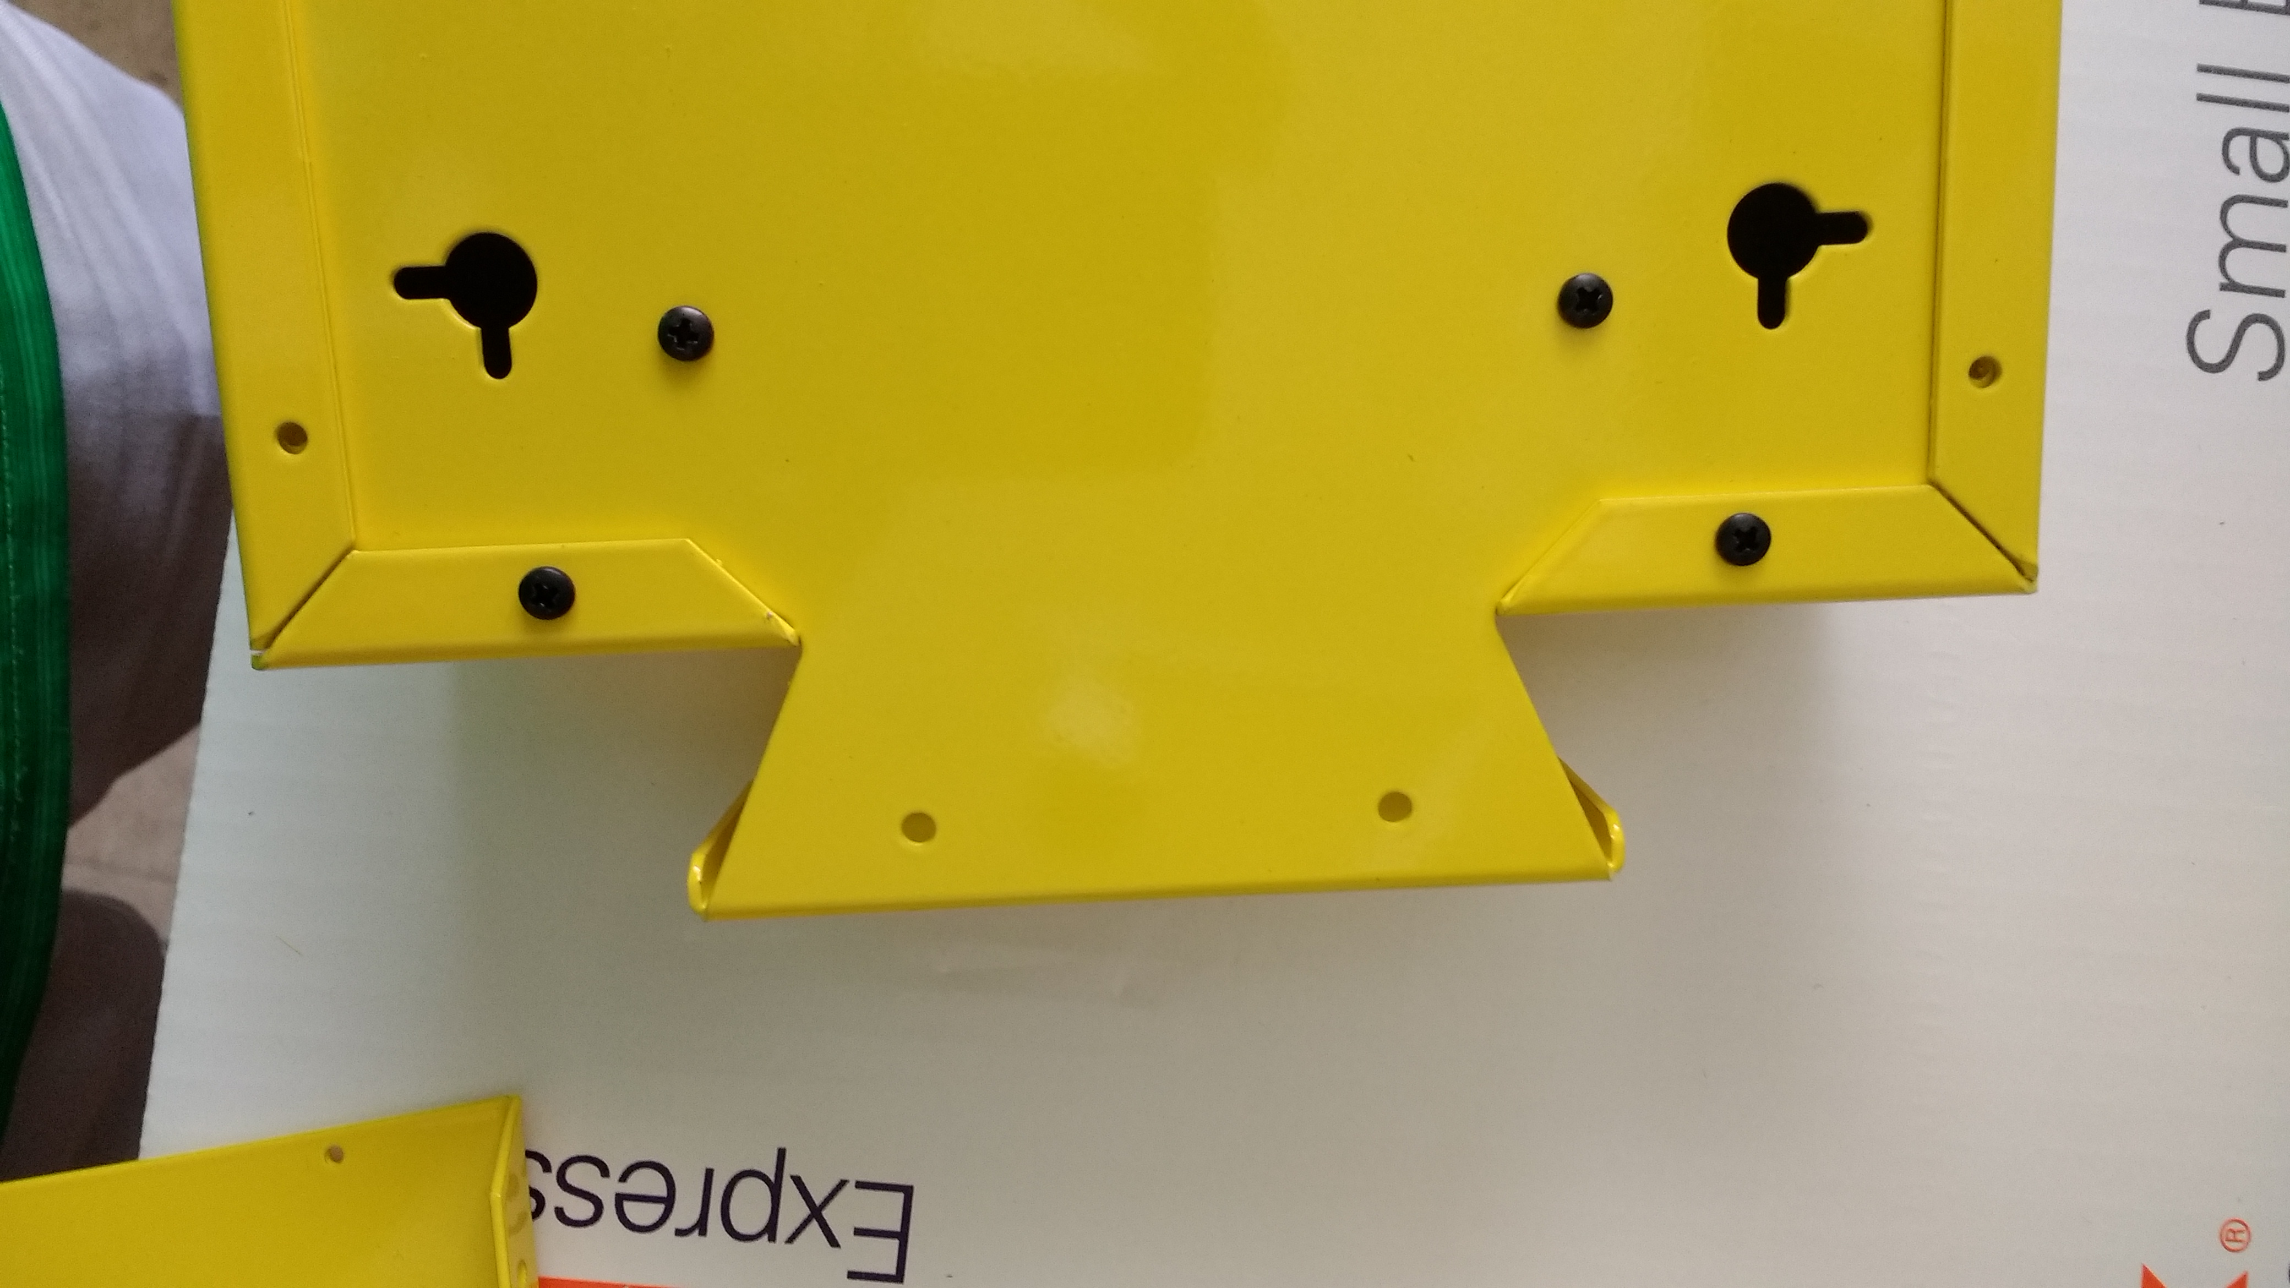
Now work your way up the sides of the case with the screws, three for each side. The bottom and top screws on each side should also get rubber footings.
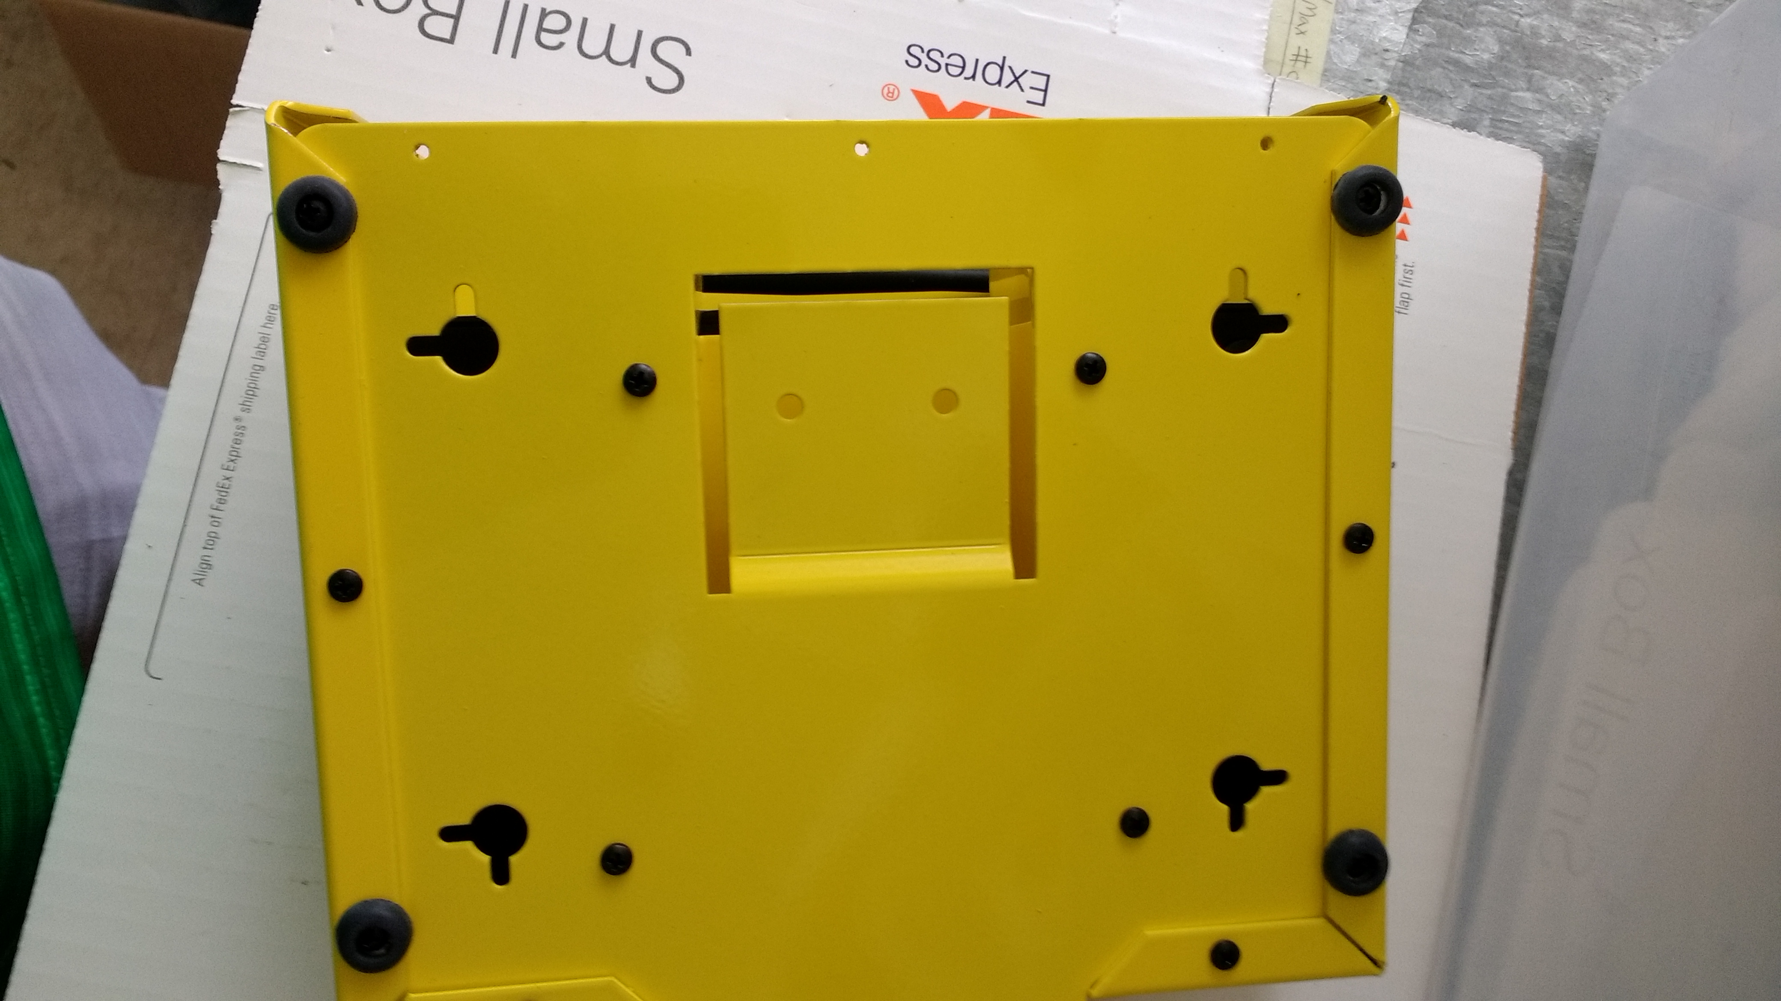

Installing the Power Jack cable
Now locate the power jack extension.
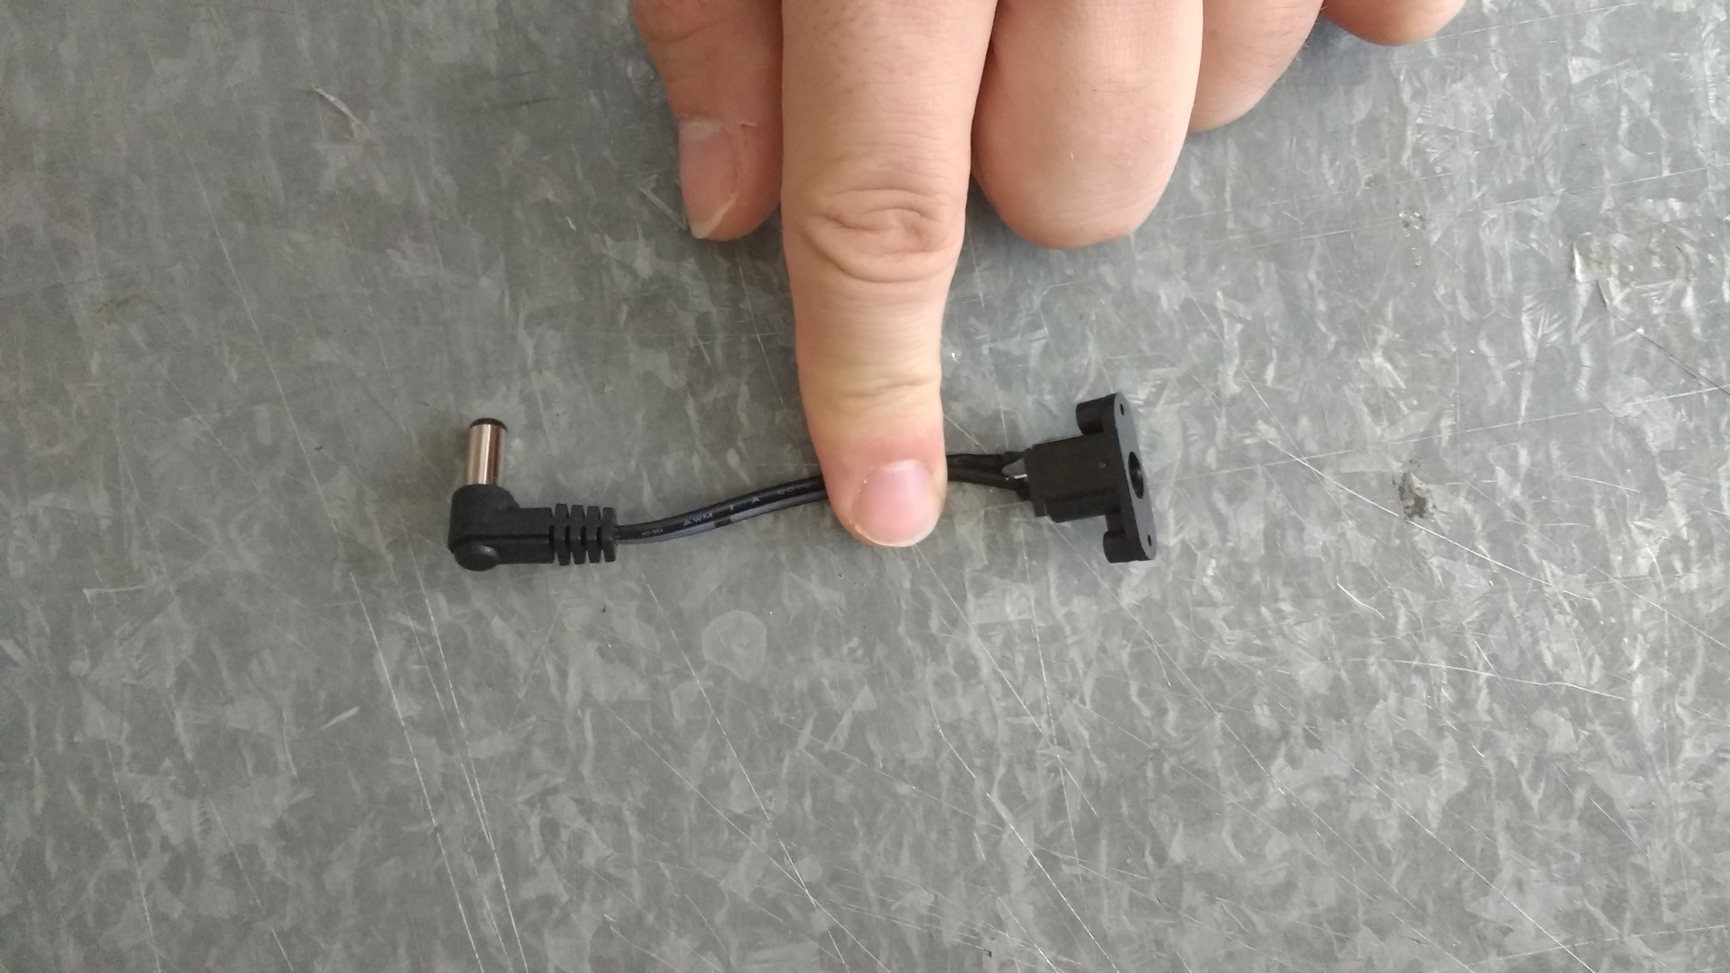
Line the screw holes in the power jack to the screw holes in the case.
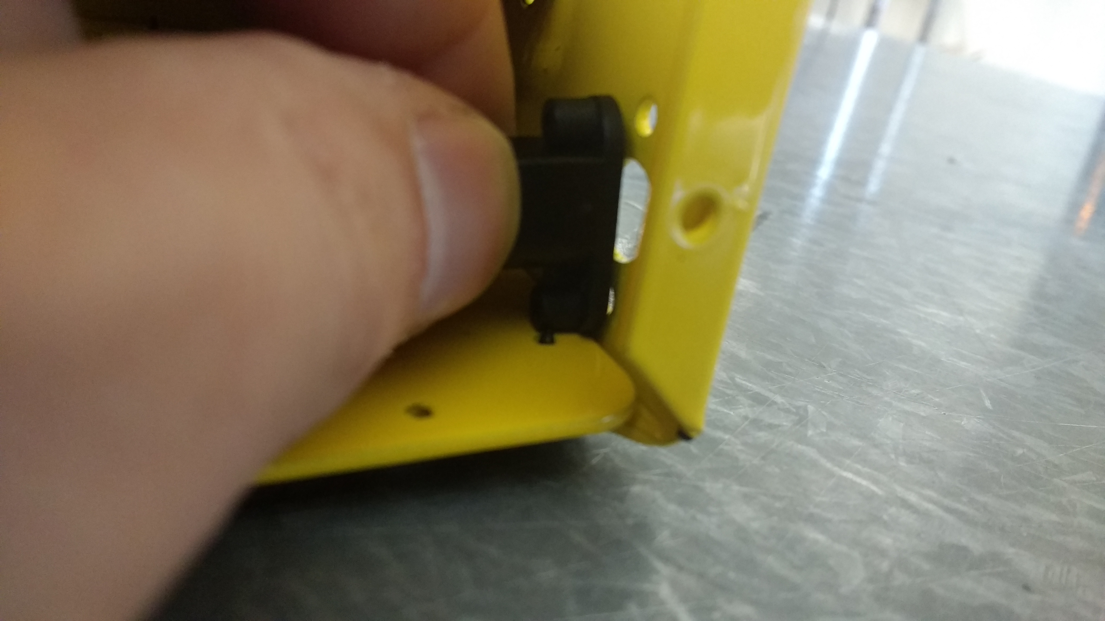

Secure the power jack to the case with two power jack screws, starting from the outside of the case.
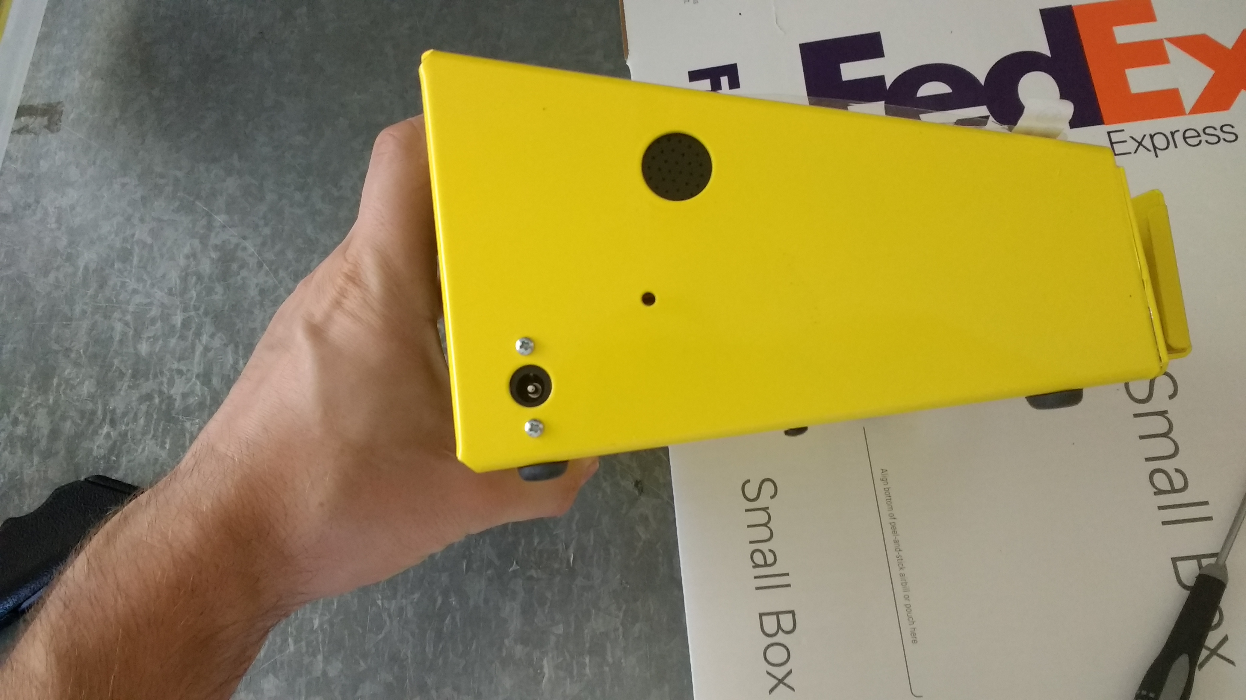

Installing the m420
Now take a Registered/Programmed m420 to place in the case. Secure the m420 to the case using two m420/MSR screws.
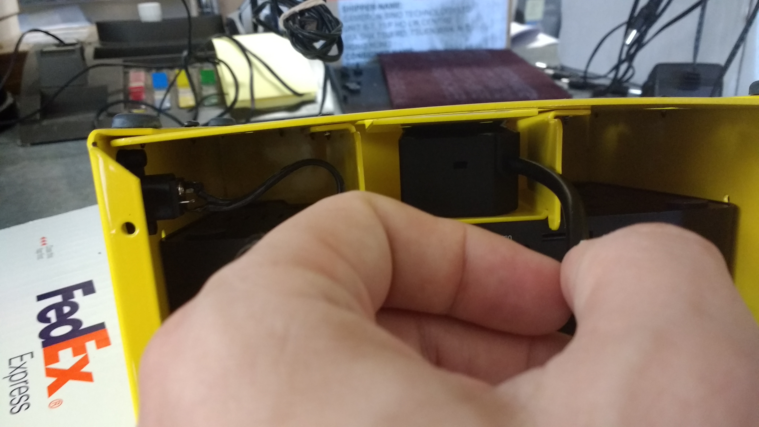
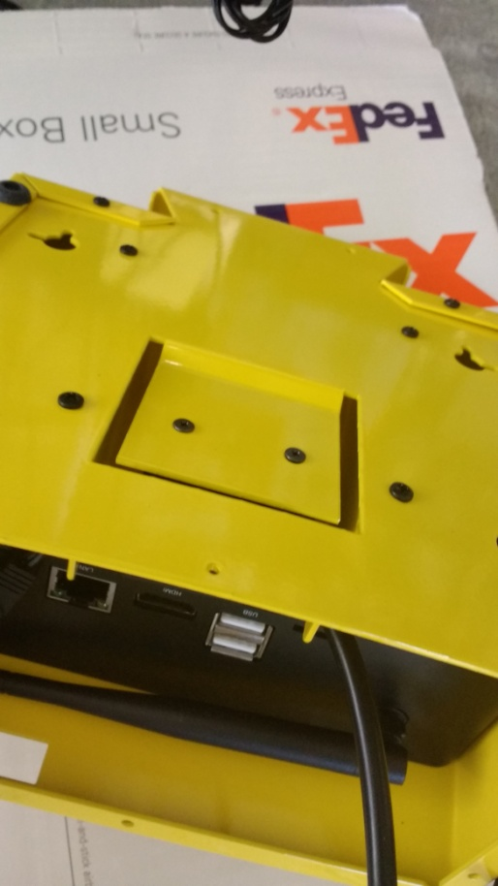
Plug the m420 into a right-angle USB extension and then plug it into the Pipo. Tuck any excess USB cord into the empty space on the side of the encasing.

Installing the MSR
Now take a Programmed MSR. Insert the USB cable in the MSR through the hole in the top of the case. Line up the MSR with the two screw holes and use two m420/MSR screws to secure it to the case. Attach a right-angle cable (opposite direction of the m420 cable) to the MSR and plug it into the USB port on the back of the Pipo.
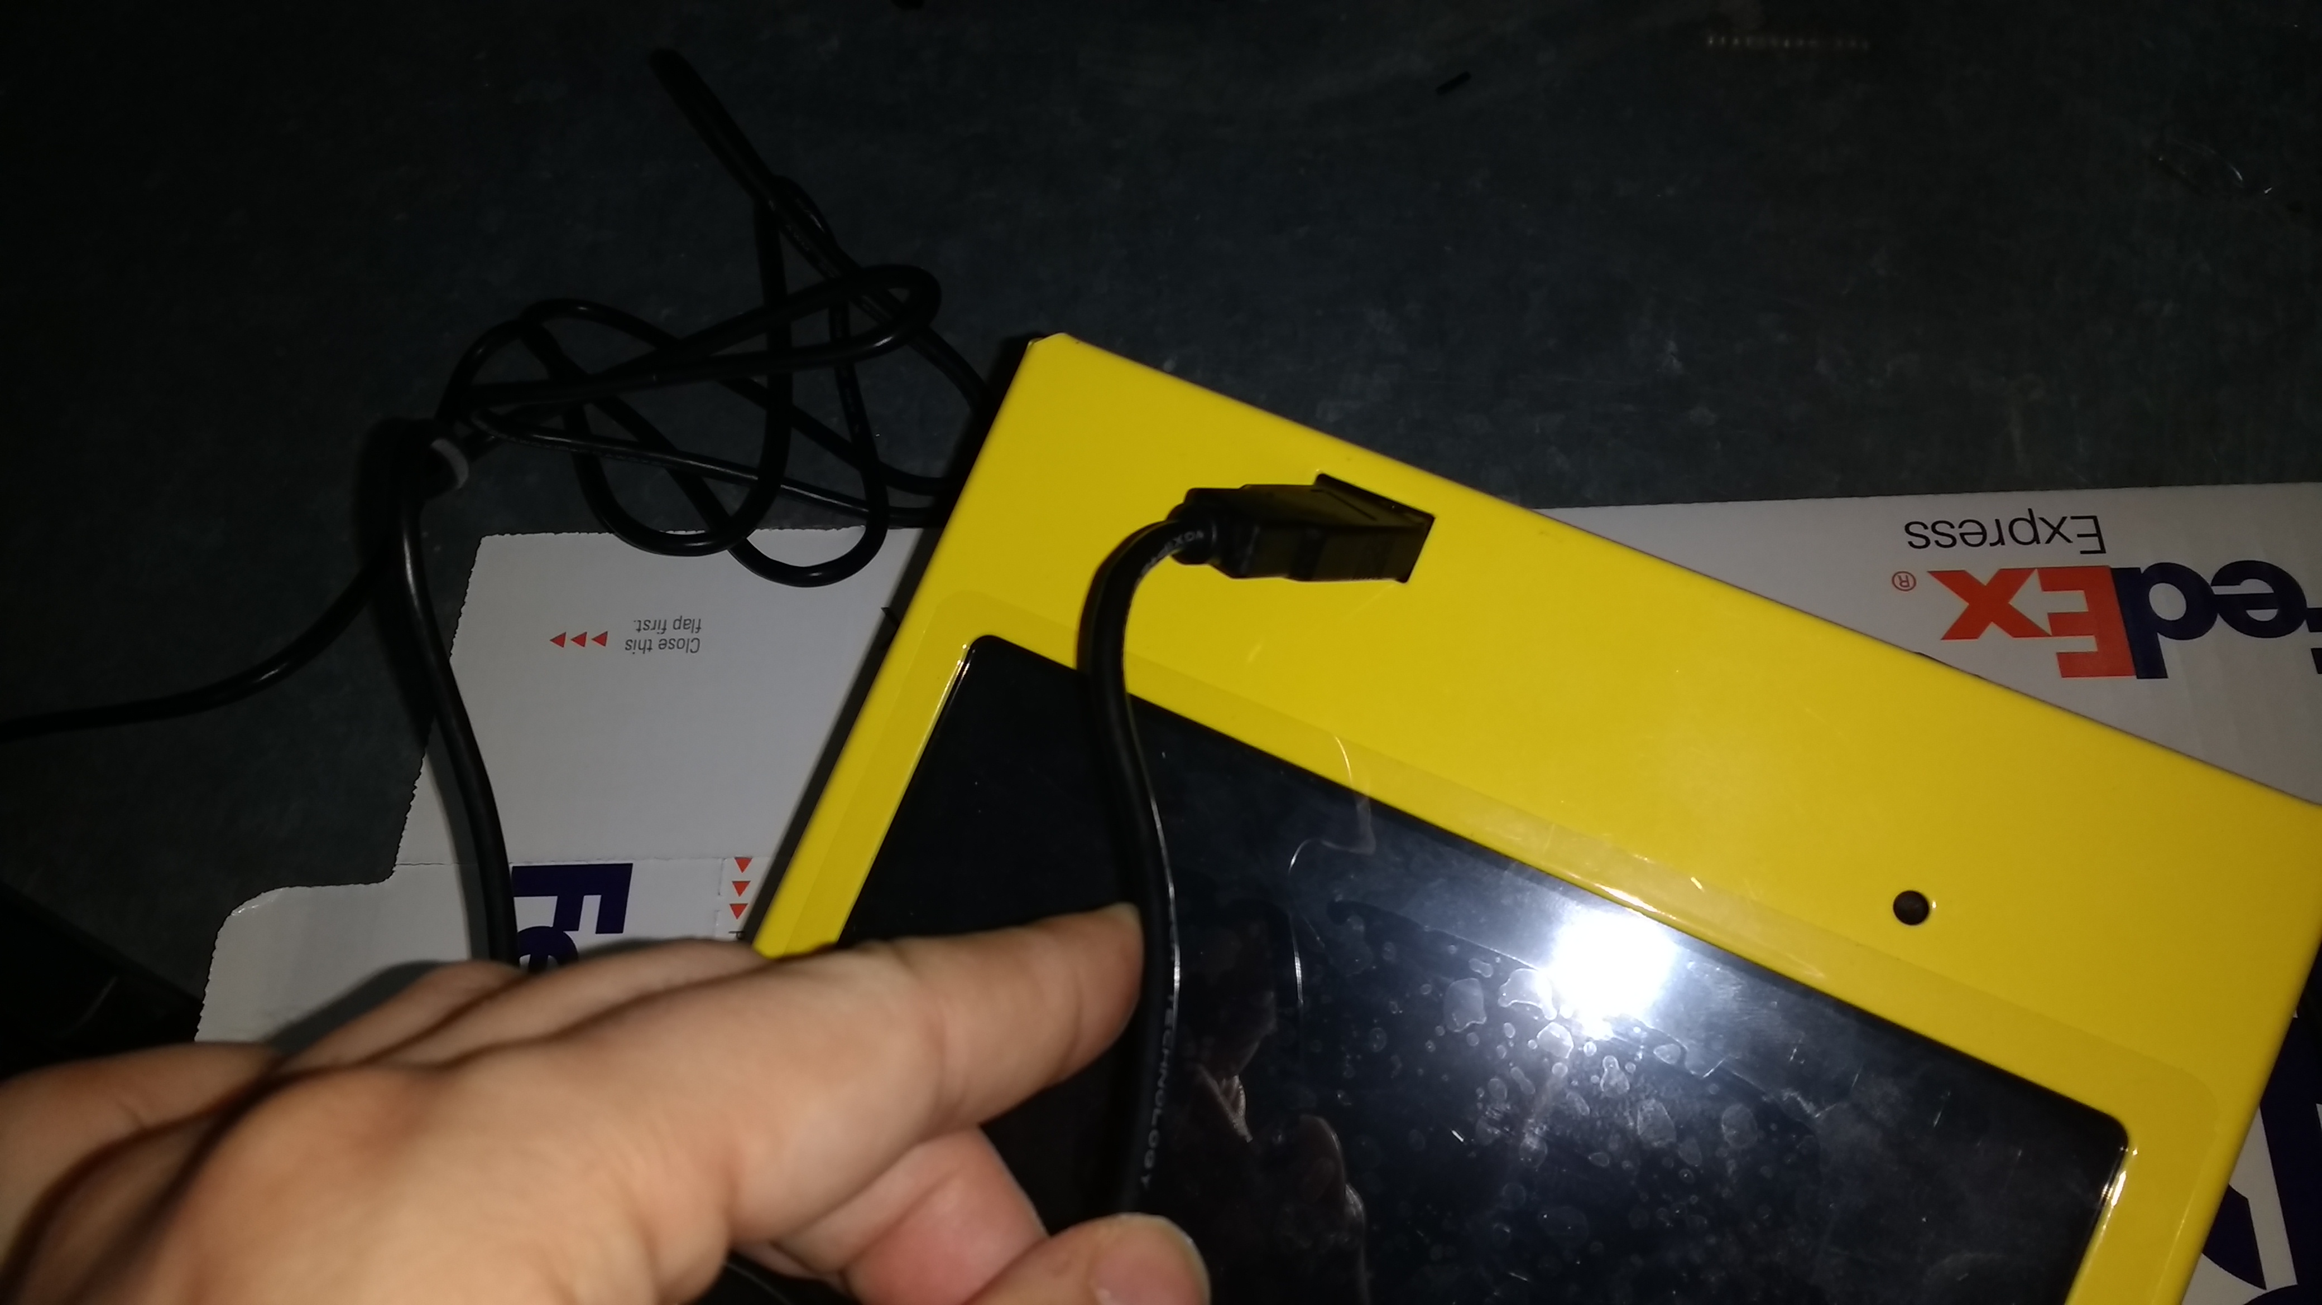

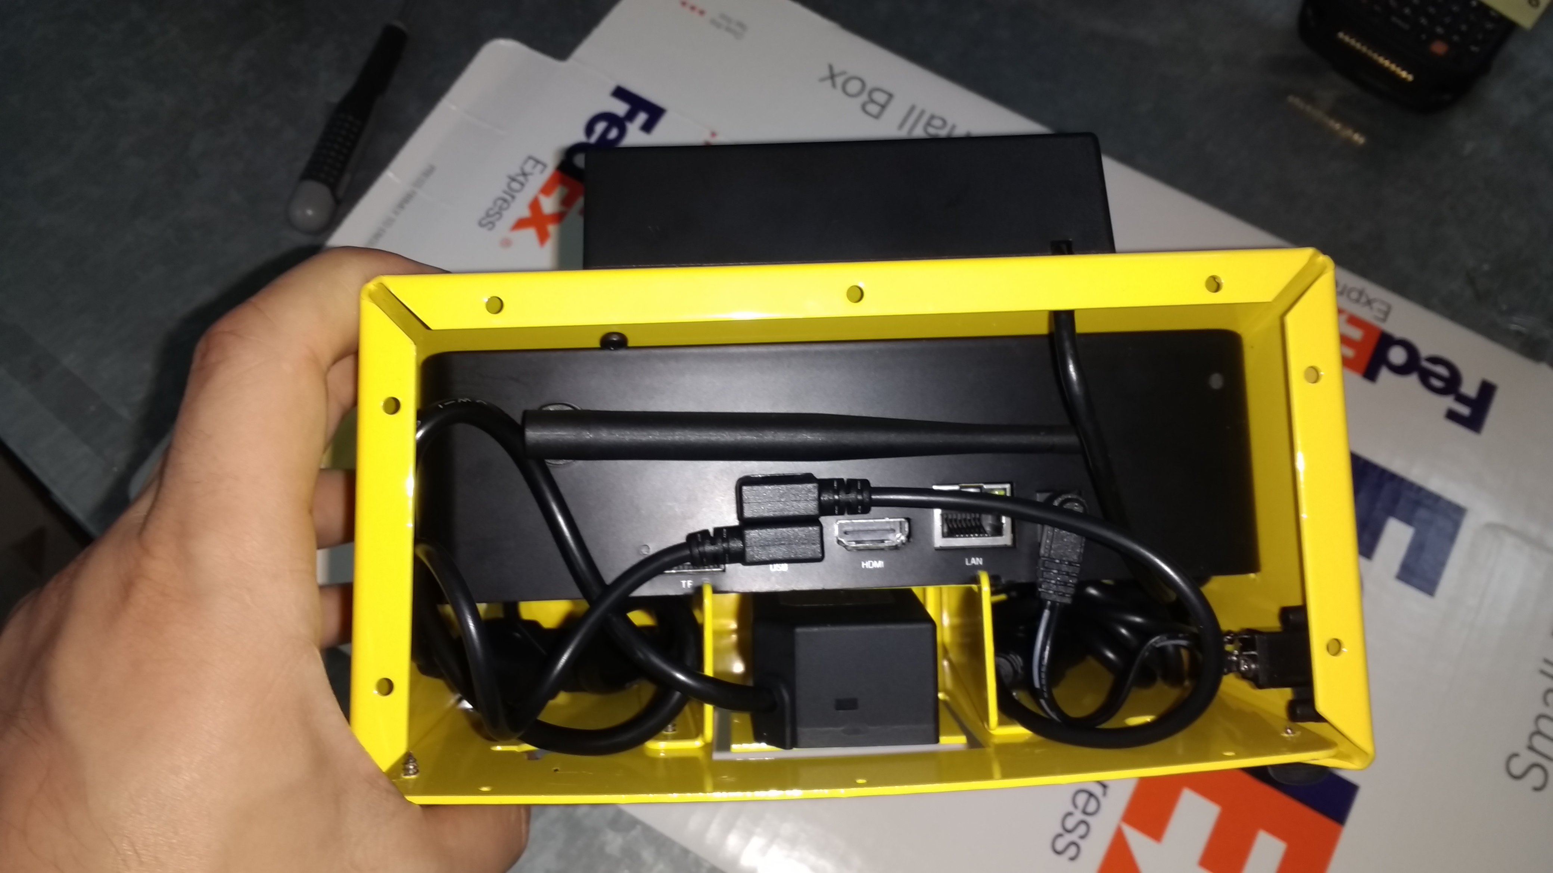
Before you finish enclosing the device, you will want to test the scanners to make sure they are working as expected.

Testing Scanners with AgeVisor Touch
- Connect both scanners to right-angle cables. The right-angle cables should not be directionally the same. Plug the connected cables into the two USB ports on the back of the device.
- Power on the AgeVisor Touch, if it isn’t already on.
- After the AgeVisor Touch powers on, if the AgeVisor Touch app automatically launches, quit out of it.
- Go to the Device Manager on the AgeVisor Touch (Right-Click the Start button and choose Device Manager). If the m420 is listed as a POS HID Barcode Scanner, right-click on the device in the Device Manager and choose Update Driver Software -> Browse my computer for driver software -> Let me pick from a list of device drivers on my computer -> Select HID-compliant device and then click next. This should change how the computer recognizes the m420 and now properly work with the AgeVisor Touch app.
- Launch the AgeVisor Touch app.
- Go to Settings -> Connection
- Change the Settings in the Scanner Connection Settings window to match the window below
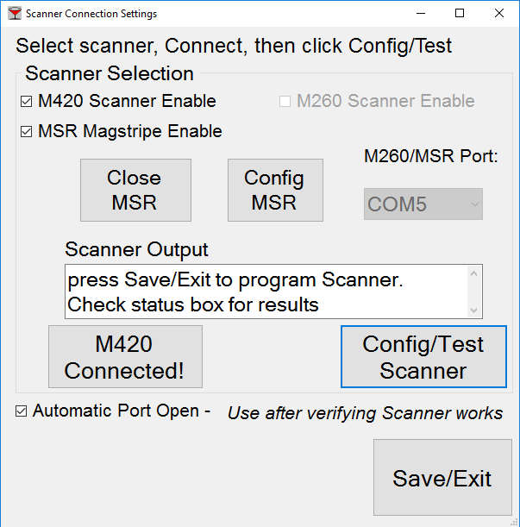
- You will need to change the M260/MSR port to be a different than the default port (COM1). If the Window does not initially allow you to change the COM1 port, then re-enable the MSR Magstripe Enable again.
- After having the correct COM port selected Click Open MSR and Config MSR. You should hear a beep from the MSR. Then press Connect M420 and Config/Test Scanner.
- Check the box that says Automatic Port Open.
- Press Save/Exit.
- After connecting the scanners, test the 2 scanners with multiple IDs

Finishing enclosing the case

Take the back plate for the case and slide it behind the edges of the case. After it is in place, apply the 10 case screws the back place.

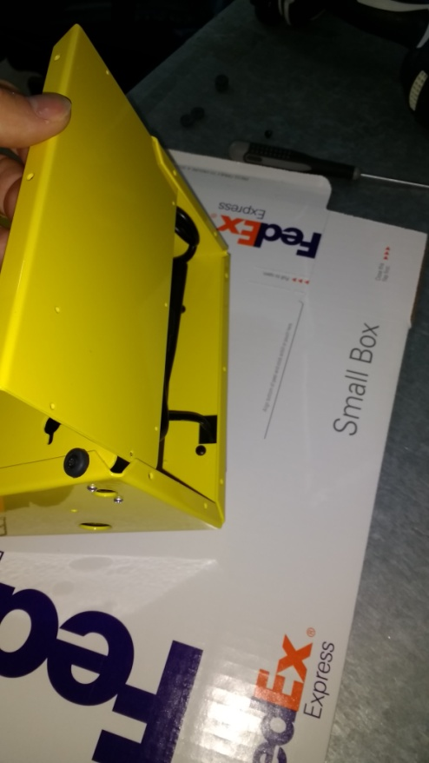

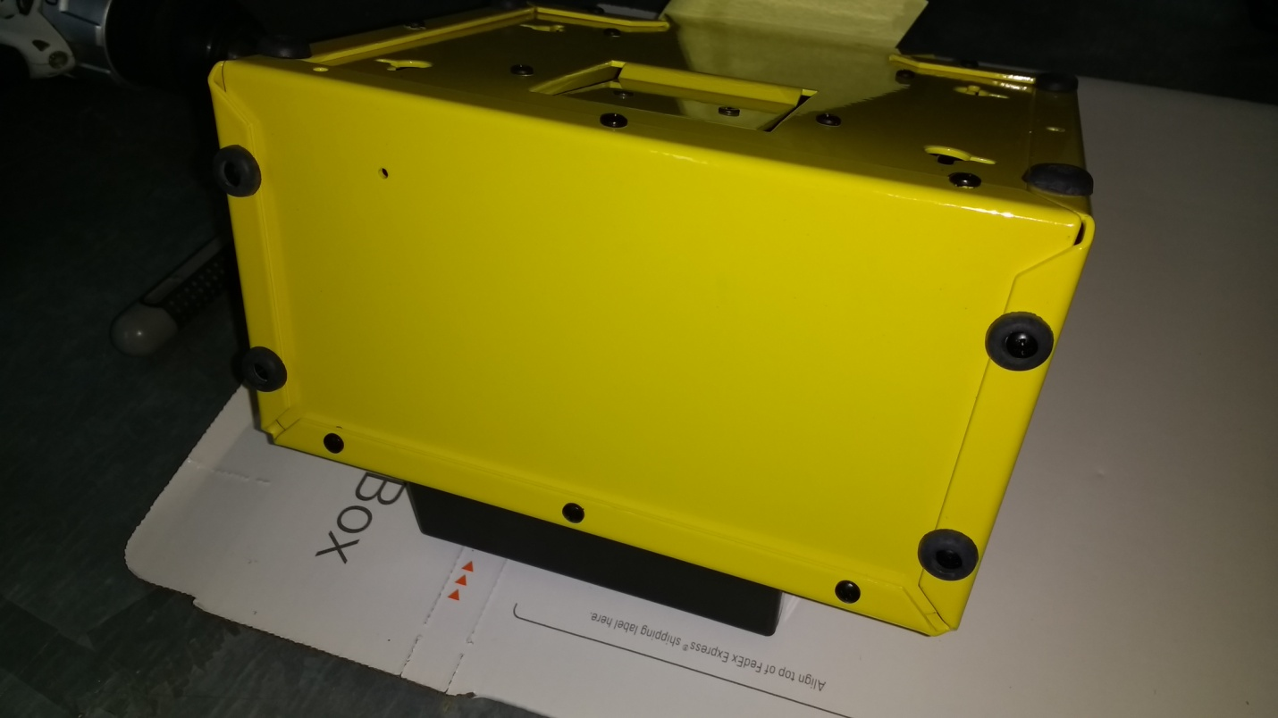

Finished AgeVisor Touch

