Exporting Raw Data from the IDVisorPro

- Exit the Application from the Home screen: Setup->Close Application (you will need the pin code 5678)
- Go to the My Device Icon and navigate to: Program Files->IDVisorPro->Log and look for the file: tkwk1 or tkwk2.
- Use the stylus or finger, press and hold on icon – wait for menu to pop up, then select Copy or select the file and then via the file explorer menu click edit->copy.
- Use the Up Arrow icon on the Device Explorer to navigate to: Storage Card and paste the tkwk log file to the storage card.
- Click on the x in the upper right corner to exit the Device Explorer, and double tap the IDVisorPro Shortcut. This restarts IDVisor Pro software.
- Go to Setup->Database and export the Customer file, follow the instructions and place the device in the cradle and connect the cradle’s USB cable to the PC. The PC may have to install drivers, wait until the scanner is recognized as an external drive (see screen shot below)

- 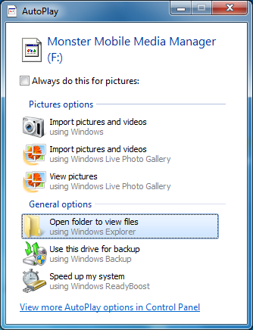

- Choose Open folder and locate the file tkwk1 or tkwk2 on the storage card. Copy and paste the file from the IDVisorPro Storage card to the PC, so you can e-mail the file to TokenWorks. Please zip the file before sending it and then email to support@tokenworks.com. Please send another email without any attachments stating you’ve send us this file so we can confirm reception. Our email server may block file attachements so this second email lets us know you are trying to send us a file.
- Disconnect the USB cable, and then Click Close on the IDVisorPro export Screen.

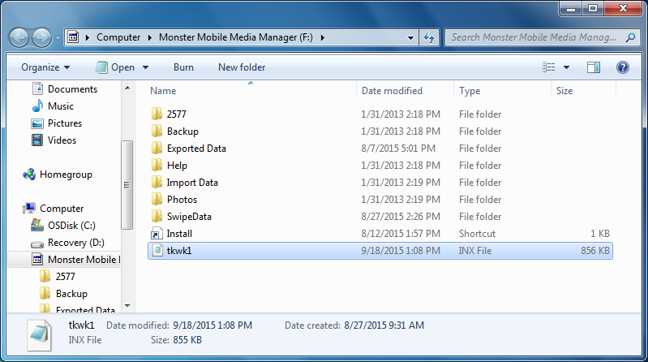

After we receive the file, we will look at the data and via email advise on next steps.
Thanks for your patience.
TokenWorks Team

