How to program M430 Scanner to be used with AgeVisor Touch

Items Needed:
- M430 Scanner
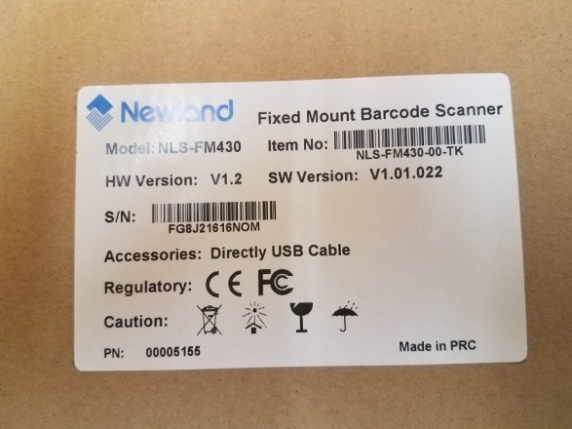
- AgeVisor Bottom Plate
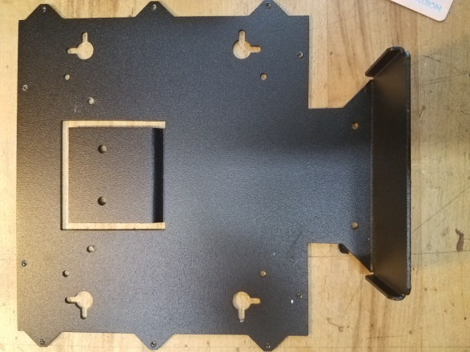
- M430 Programming Barcodes
  - Code Programming Off
  - Code Programming On
  - Select USB HID-POS
- A computer with Tokenworks ScannerReg App loaded onto it.

STEPS:

- Connect M430 to PC Via USB- Wait until Drivers Have Installed.
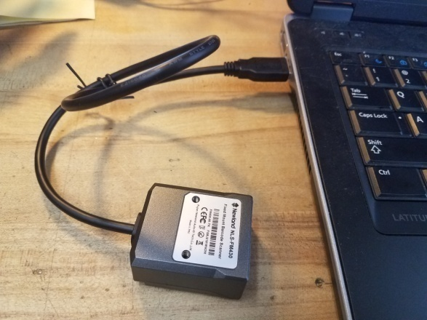

- Scan “Code Programming ON” barcode:
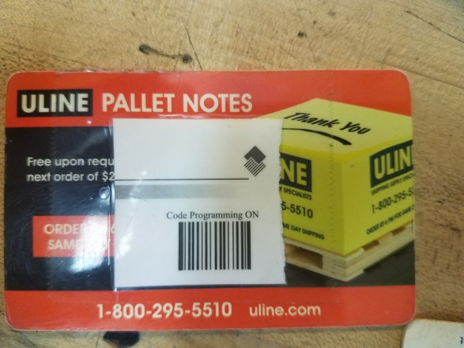

- Scan “Select USB HID-POS” barcode:
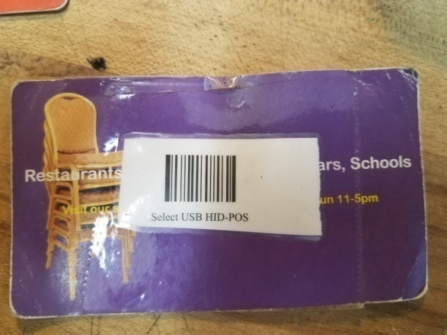

- Scan “Code Programming OFF” barcode-Wait until drivers have installed:
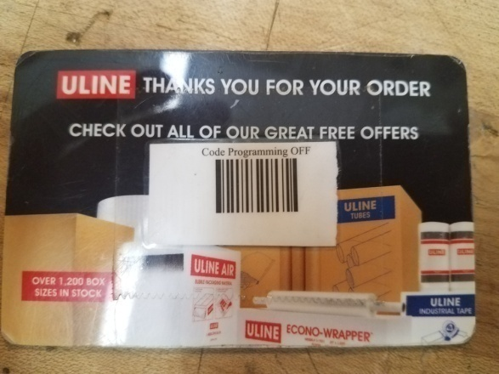

- Open Scanner Registration App:
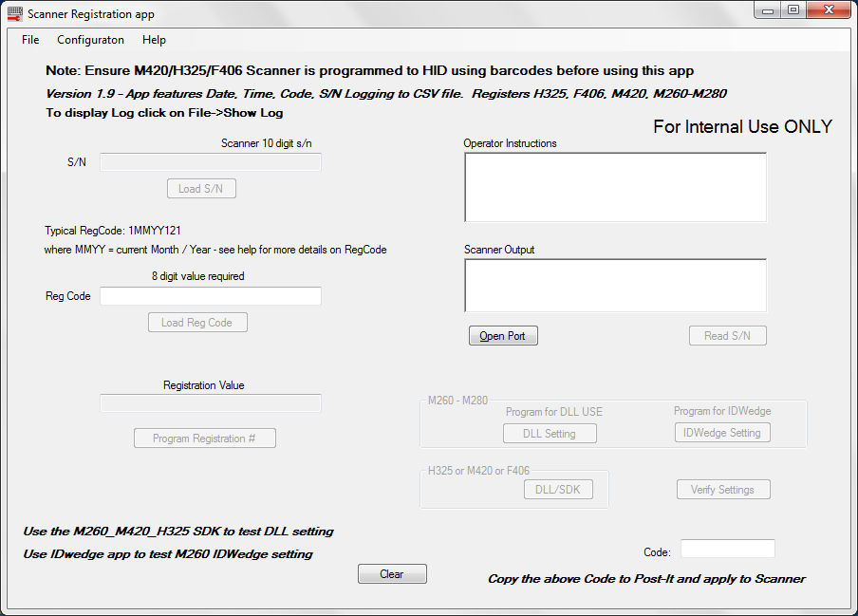

- Enable “MF420 Enable Scanner Enable” option in Scanner Registration App under Configuration>Scanner Settings. Then Click "Done":
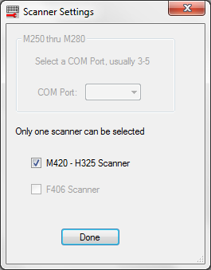

- Click Open Port
- Followed clicking by Read SN
- Enter the Registration Code then click Load Reg Code [The Registration code is 1MMYY121 where MM represents the month for example January would be represented as 01, and YY represents the year, 2019 would be represented as 19 so a completed registration code would like like 10119121 for January, 2019]
- Click Program Registration,
- Select DLL/SDK Setting,
- Finally Select Verify Settings.
- You will be greeted with the screen below if you programmed it succesfully:
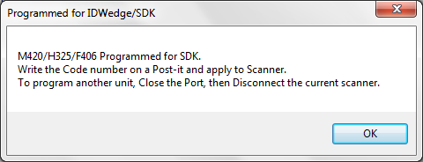

- Click the Close Port Button and unplug the M430 from the computer.

- To check to see if the M430 was programmed correctly, you can select File>Show Log. Scroll to the bottom for the most recent programmed M430 and it will show the serial number, how it was programmed, and when it was programmed.
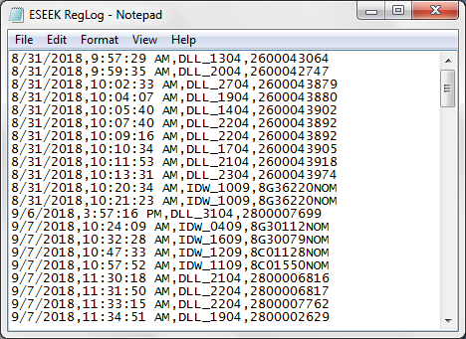

- Place the M430 on the AVT Bottom Plate so that it is centered. The screw holes should line up with the Bottom plate's perforated holes as shown below:
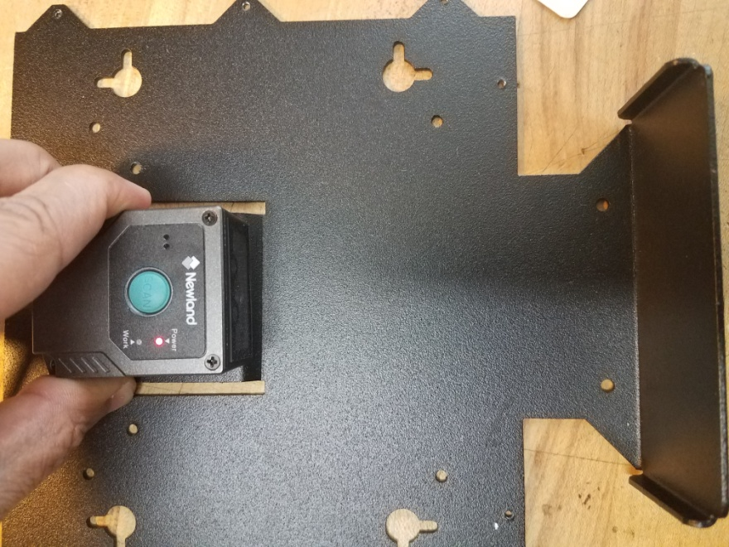

[Note:The M430 should still be connected to the computer via USB]
- Using an ID with a barcode that is aligned to the left or right (as shown below) test the M340 by placing an ID into the AVT bottom plate:
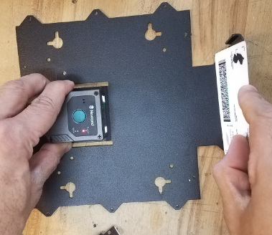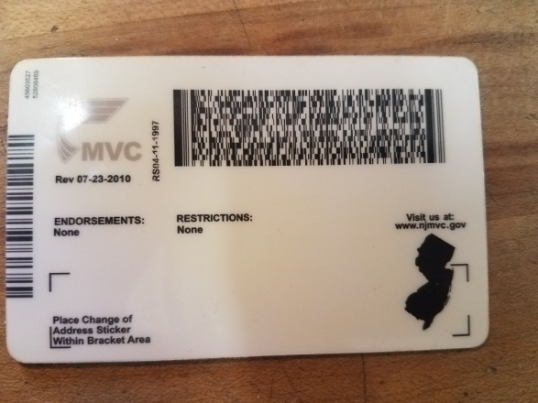

12) The M430 should scan the ID within the bottom plates divots on the right and left. If you have to move the ID outside of the two divots place that M430 aside to be further tested. If it scans properly, put it back in the box and place in on the shelf. You are now finished.

